1a)Study on Virtualization types and tools
AIM:
To study virtualization, its type and tools associate with the each virtualization.
Virtualization
Virtualization is the process of creating a virtual version of something, such as a server, a desktop, a storage device, an operating system, or network resources.
Types:
1) Hardware Virtualization
a. Full virtualization
b. Para virtualization
c. Type 1 & Type 2 Hypervisors
2) Operating System Virtualization
3) Server Virtualization
4) Storage Virtualization
5) Network Virtualization
6) Desktop Virtualization
7) Application Virtualization
1)HARDWARE VIRTUALIZATION:
Definition:
The abstraction of physical computing resources from the software that uses those resources, allowing multiple full operating systems (Virtual Machines) to run simultaneously on a single physical machine.
Tools: VMware vSphere/ESXi, Microsoft Hyper-V, KVM, Oracle VM, Citrix Hypervisor
Diagram:
a). Full Virtualization
Definition: A technique where the hypervisor completely simulates the underlying physical hardware, allowing unmodified guest operating systems to execute isolated instructions via binary translation or trapping.
Tools: VMware Workstation, VirtualBox, Parallels Desktop, Microsoft Virtual PC
Diagram:
b. Para-Virtualization
Definition: A technique where the guest operating system is explicitly modified to be aware that it is running in a virtual environment, communicating directly with the hypervisor via "hypercalls" to boost performance.
Tools: Xen, Microsoft Hyper-V (with integration services), IBM z/VM
Diagram:
c.Bare Metal(Type 1) & Hosted( Type 2) Hypervisors
(Bare Metal)Type 1
Hypervisors that are installed and executed directly on top of the bare physical hardware without an intermediate host operating system, maximizing performance and security.
Tools:VMware ESXi, Microsoft Hyper-V (Server), Xen, KVM
(Hosted)Type 2
Hypervisors that run as a software application on top of a standard host operating system (like Windows, macOS, or Linux), primarily used for development and testing.
Tools: VirtualBox, VMware Workstation, Parallels Desktop
Diagram:
2)OS VIRTUALIZATION:
Definition:
A lightweight virtualization model where the kernel of a single host operating system is shared to create multiple isolated user-space instances (containers) instead of full virtual machines.
Tools: Docker, LXC (Linux Containers), Podman, OpenVZ
Diagram:
3) Server Virtualization
Definition:
The process of masking server resources (including the number and identity of individual physical servers, processors, and operating systems) from server users by splitting a physical server into smaller virtual servers.
Tools: VMware vSphere, Microsoft Hyper-V, Red Hat Virtualization (RHV), Citrix Hypervisor
Diagram:
4) Storage Virtualization
Definition: The pooling of physical storage arrays from multiple network storage devices into what appears to be a single, unified storage volume managed from a central console.
Tools: VMware vSAN, Ceph, OpenMediaVault, FreeNAS/TrueNAS
Diagram:
5) Network Virtualization
Definition: The abstraction of physical network resources (switches, routers, links) into logical network spaces that can be managed programmatically as Software-Defined Networks (SDN)
Tools: VMware NSX, Cisco ACI, Open vSwitch, AWS VPC
Diagram:
6) Desktop Virtualization
Definition: The separation of the logical desktop environment from the physical machine, often hosting desktop images on a centralized server via a Virtual Desktop Infrastructure (VDI)
Tools: Citrix Virtual Apps and Desktops, VMware Horizon, Microsoft Remote Desktop Services (RDS)
Diagram:
7) Application Virtualization
Definition: Encapsulating computer programs from the underlying operating system on which they are executed, allowing them to run in isolated environments or streams without native local installation.
Tools: Microsoft App-V, Citrix Virtual Apps (XenApp), VMware ThinApp, Cameyo
Diagram:
RESULT:
Thus the study of virtualization, its types and tools has been studied successfully.
Ex.no:2
2a) Creating a VM and adding Storage, Memory, and Network to a VM

Aim:
To create a VM and adding storage ,memory and network to a VM in the oracle virtual box
Steps:
- Open Oracle VM VirtualBox Manager and Click the "New" button
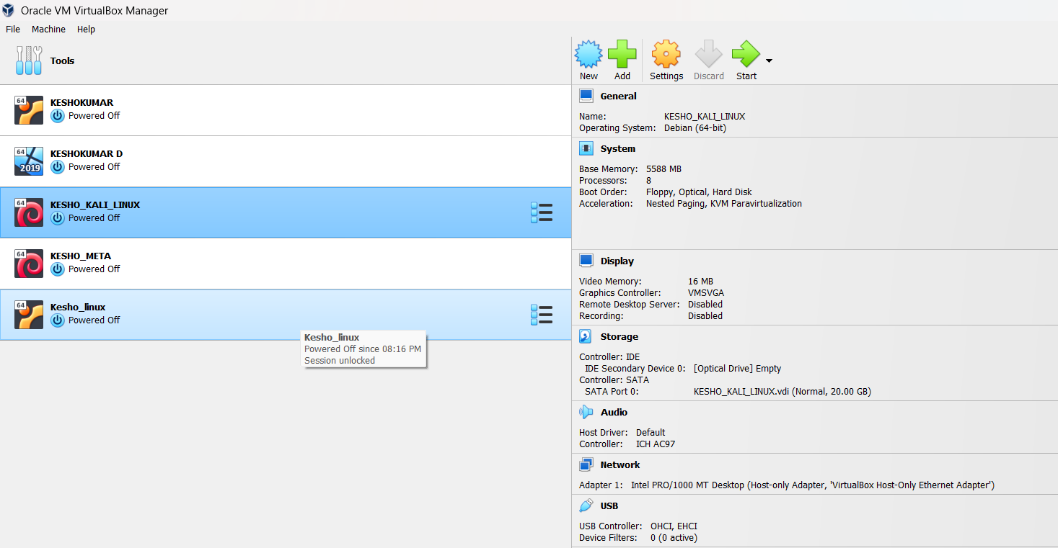
2) Fill the name: (KESHO_2A) Type: Linux Version: Ubuntu (64-bit) or your chosen OS and Click Next
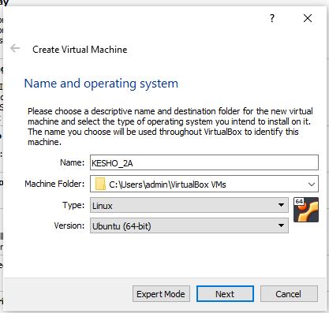
3) Allocate Memory (RAM) .Set the memory size 4gb has been set below Don’t exceed 50% of your physical system RAM Click Next
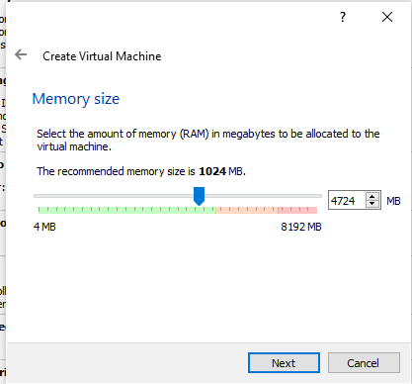
4)Click use an existing virtual hard disk. Click Next Dynamically allocated → Click Next Set disk size (e.g., 20 GB)Click Create
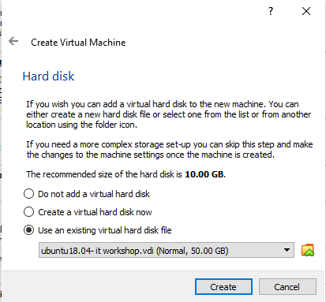

5) Configure Network Adapter Go to Settings → Network Ensure Adapter 1 is: Enabled Attached to:Bridged Adapter (for internet + LAN access), or Host-Only Adapter (for communication with host only) Click OK Then new vm has been created
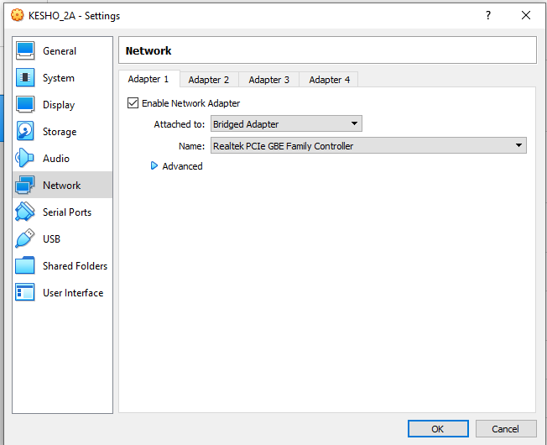
Execution of java program to test the execution time between vm (Ubunttu) and host(Windows)
1)To find the sum of digits between 1 to max of long datatype
Steps to Execute in Ubuntu (Virtual Machine)
- Open the Terminal.
- Create a Java source file using the command:
gedit filename. java
- Type the Java program in the Gedit editor.
- Save and close the editor.
- Compile the program using:
javac filename.java
- Execute the program using:
java filename
Code:
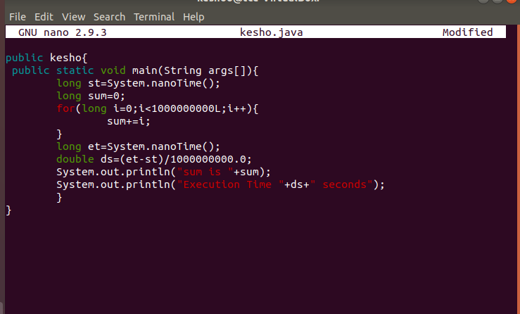
Execution time in Linux
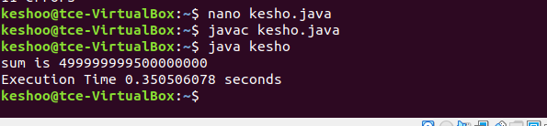
Execution time in Windows
Steps:
- Open notepad in windows.
- Type the program and save it as filename.java
- Open Command Prompt in windows
- Navigate to the folder containing the Java program:
cd <path_to_program> example:D:/
- Compile the program: javac filename.java
- Run the program: java filename
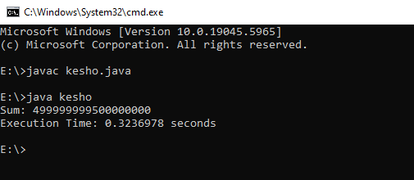
From the above the execution time in linux is 0.35 s where the time taken by the windows is 0.32 this clearly tells that the windows host is faster than the linux vm

RESULT:
Thus the Creation of VM and adding Storage, Memory, and Network to a VM has been created successfully and output has been verified

2b) VM-VM ping, VM-Native Ping
Aim:
To check the victim or target is alive between VM -VM and VM-native (host) using the ping command .
Steps: Before ping commands
- Both VMs are Powered ON
- Both are connected to the same network (e.g., Host-Only or Bridged)
- Each VM has a valid IP address (like 192.168.56.x)
- Firewall is disabled or ICMP is allowed

Find IP Addresses
  - Using ip a or ifconfig in VM
  - Using ipconfig in windows
To enable VM-to-VM and VM-to-host ping communication in VirtualBox, first set both VMs' network adapters to "Host-Only Adapter" (e.g., vboxnet0) via VirtualBox → Settings → Network. Then, start both VMs and run ip a inside each to find their IP addresses (usually 192.168.56.x). On each VM, disable the firewall using sudo ufw disable and optionally flush iptables with sudo iptables -F. On the Windows host, enable ICMP ping by opening "Windows Defender Firewall with Advanced Security", going to Inbound Rules, and enabling "File and Printer Sharing (Echo Request - ICMPv4-In)". Now, use ping <other_VM_IP> from one VM to the other, and from the host, use Command Prompt to ping each VM’s IP (e.g., ping 192.168.56.101)

1)VM – NATIVE:
To check the target is alive between the host and vm using ping commands
IP address of windows:
Ip address of linux was 127.0.0.1
Using ping checking the vm is alive or not (ping 127.0.0.1)
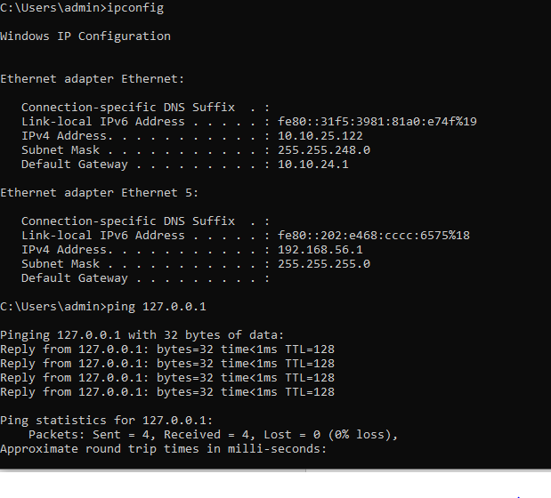
Ping for windows:
Using ping checking the host is alive or not (ping 127.0.0.1)
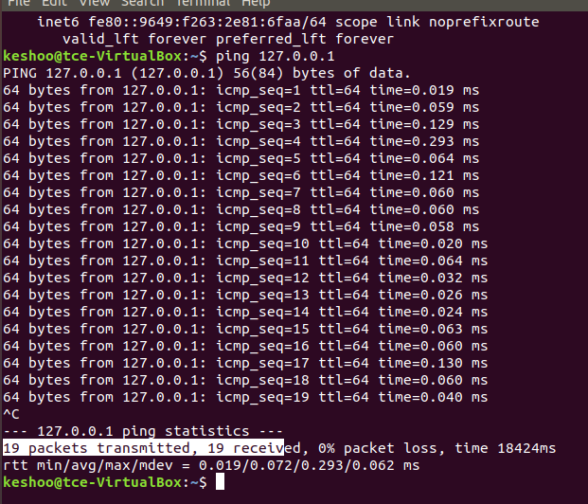
VM- VM
I am using linux (one was ubunttu) and another was (Kali linux )
Ping in Linux ubunttu:
Using ping 192.168.56.103 (Checking the kali linux is alive or not using ping in ubunttu)
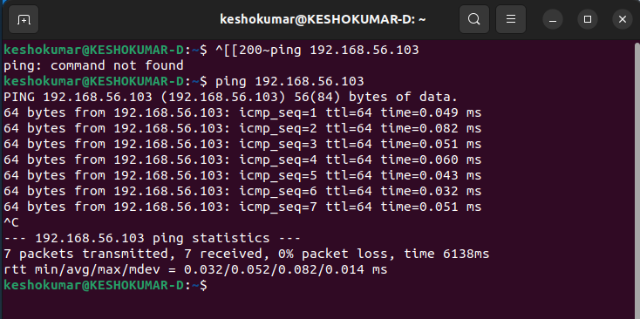
Using ping 192.168.56.101 (Checking the ubunttu linux is alive or not using ping in kali linux)
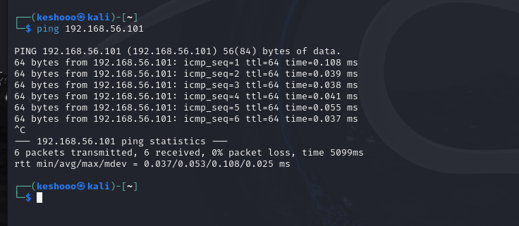
RESULT
Thus the checking the victim or target is alive between vm -vm and vm-native using the ping command has been executed successfully and output has been verified.
Ex.no:3
3)Cold Migration of VM from one host to another

Aim:
To perform cold migration of a virtual machine (VM) from one host to another using the export/import appliance method (OVA format) in order to transfer VM configurations and disk data seamlessly while the VM is powered off.
STEPS:
Prerequisite
- VM must be shut down (powered off).
- Both systems (source and destination) must have VirtualBox
- Ensure enough storage on destination host.
1)Created a java file to check whether the same file exist in vm after imported(cold migrated ) in another system
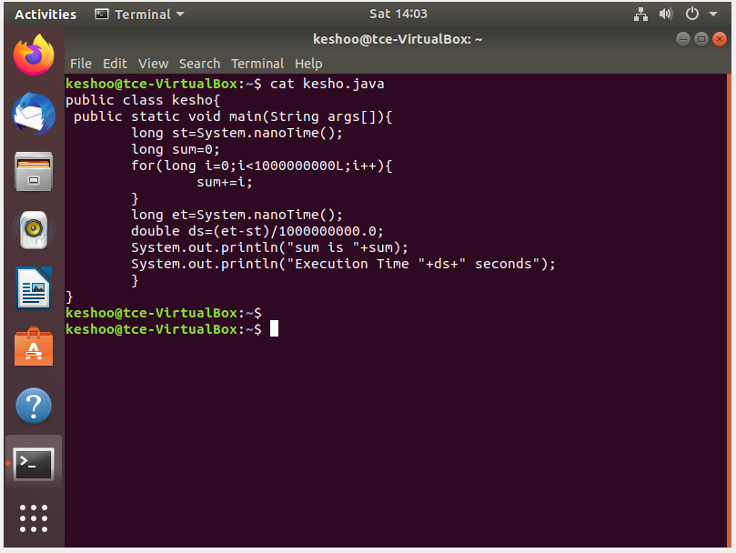
2)Shut down the VM completely. Open VirtualBox and select the VM → Click File > Export Appliance (or File > Export OVF).
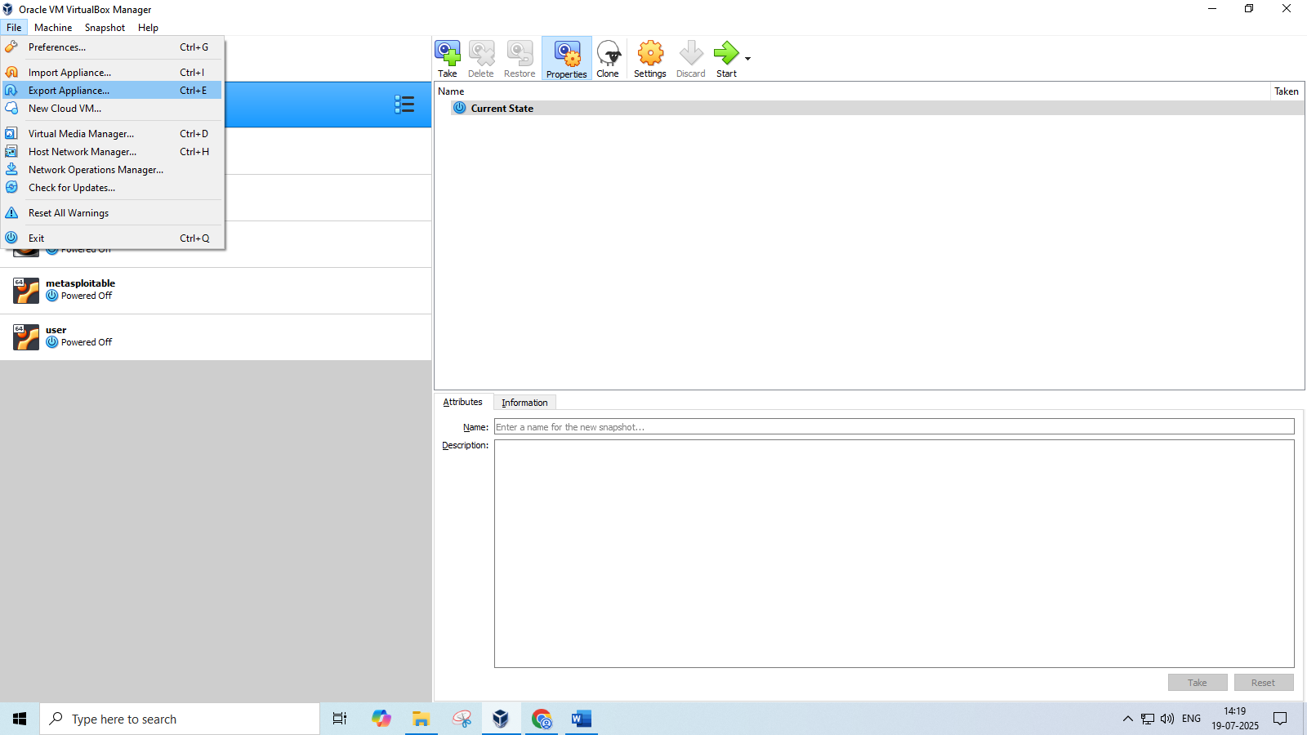

3) Select the vm which you want to export
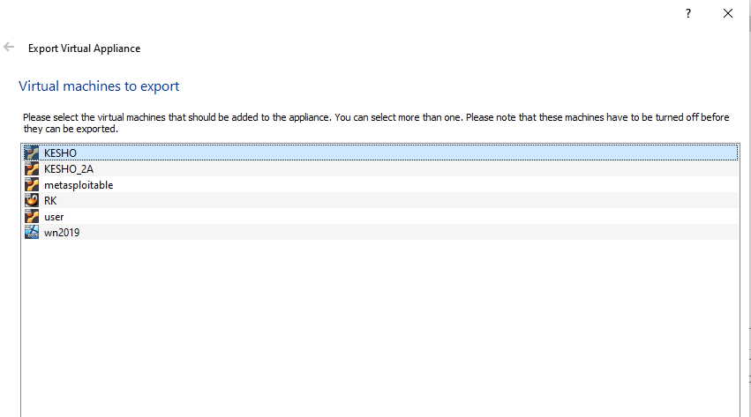

4)Select the format which you want to export ova or ovf file format and select the path where you want to export in the file system
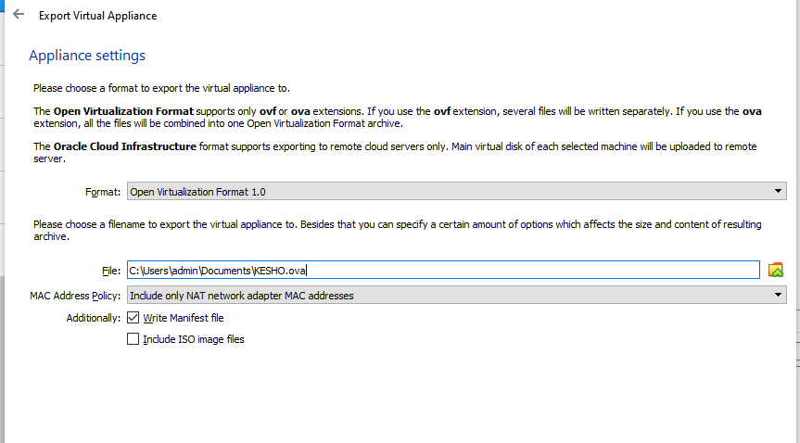
5)Click export to (export appliance to the file system where you selected the location)
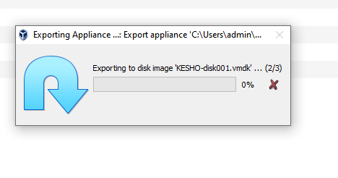
6) Check the folder whether the ova image has been present in the folder
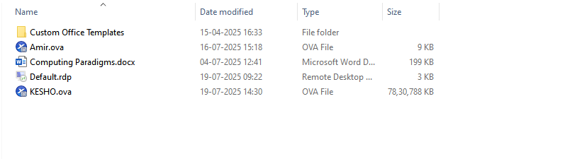
7) Copy the image to the external device via internet , USB etc I am using the usb and stored in my smartphone y3005G.

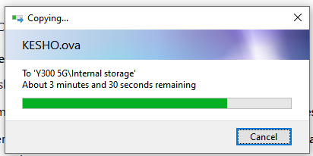
8)Copy the image from your external device to the destination machine via usb
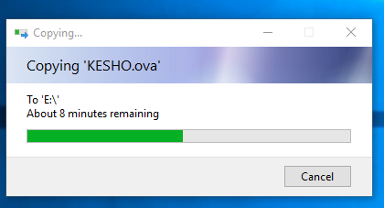
8) On the Destination Host: Import the OVA Open VirtualBox Go to File > Import Appliance (or File > Open). Browse and select the .ova file you transferred.
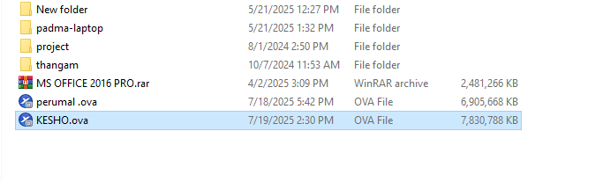

9) Import the image by import appliance in the file ->import appliance
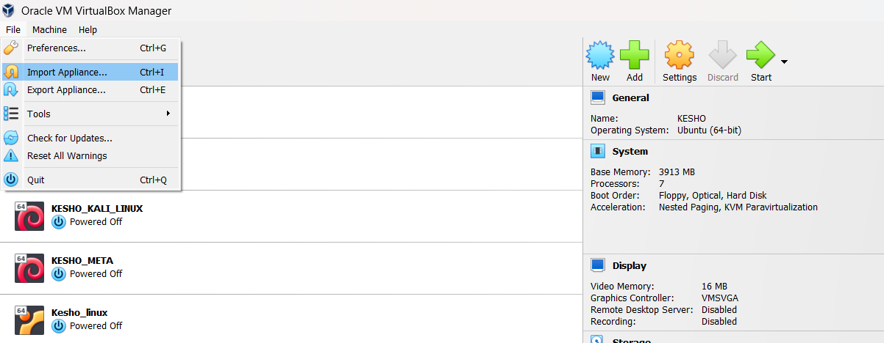
10)Now the image has been importing
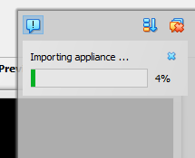
11)Check whether the vm is shown in the oracle virtual box and open it

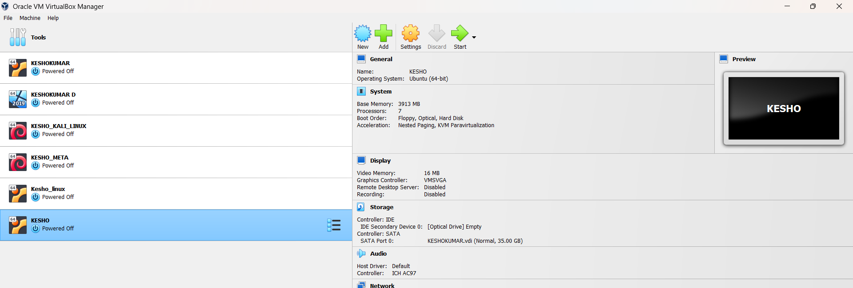
12)Open the java file which you saved first using the linux commands cat kesho.java
And its verified that the file are located and cold migration has done
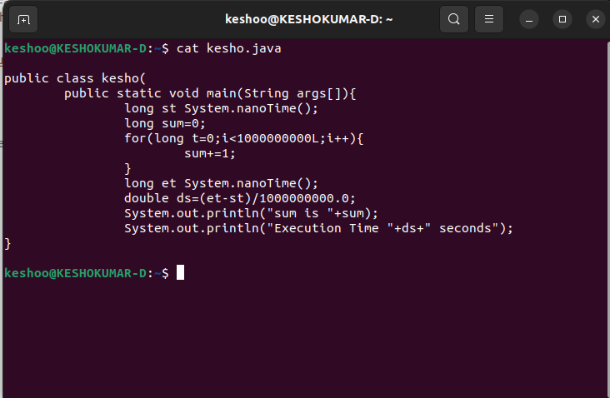

RESULT:
The virtual machine was successfully migrated to the destination host in a powered-off state(cold migration) using the OVA export/import method. All configurations and data were retained, and the VM booted up and functioned correctly on the new host.
Ex.no:4
4 a) Installation of Citrix XenServer 4 b) Live Migration of Virtual Machines using Xen Center
Aim:
To install and configure Citrix XenServer for virtualization of multiple operating systems , use Xen Center for graphical management of virtual machines and perform live migration of VMs between physical hosts without downtime.
Xen
Xen is a Type 1 (bare-metal) hypervisor that enables the execution of multiple virtual machines (VMs) on a single physical machine by abstracting the hardware. It supports both paravirtualization and hardware-assisted full virtualization (via Intel VT or AMD-V).
Virtualization Type: Para or Full?
Feature | Xen
Supports | Both Paravirtualization (PV) and Hardware-assisted Full Virtualization (HVM)
Default Mode | Originally designed for Paravirtualization (efficient, faster)
With Hardware Assist | Uses HVM mode for OSes like Windows (needs CPU virtualization support)

Xen Type 1 vs Type 2 Hypervisors
Feature | Type 1 (Xen) | Type 2
Runs on | Bare metal (hardware directly) | Runs on host OS
Examples | Xen, VMware ESXi, Microsoft Hyper-V | VirtualBox, VMware Workstation
Performance | High performance, low overhead | Slightly lower performance
Security | More secure (minimal layers) | Depends on host OS security

Equivalent Hypervisors to Xen
Hypervisor | Type | Notes
KVM | Type 1 (in Linux kernel) | Integrated with Linux, uses hardware virtualization
VMware ESXi | Type 1 | Enterprise-grade, GUI support
Microsoft Hyper-V | Type 1 | Windows-based hypervisor
VirtualBox | Type 2 | Desktop virtualization

Requirements for Live Migration in Xen
- Shared Storage (e.g., NFS, iSCSI, SAN): Both hosts must access the same virtual disk.
- Same CPU family: Compatible CPU features between source and destination.
- Network Connectivity: Low-latency, high-speed network between hosts.
- Xen-compatible tools: xm, xl, or XenAPI-based management like XenCenter.
- Proper Configuration: Dom0 should have migration tools enabled, with firewall ports open.

XenServer vs XenCenter
Feature | XenServer | XenCenter
Definition | Commercial distribution of Xen hypervisor | GUI-based management tool for XenServer
Runs on | Physical Server (bare-metal) | Windows desktop (client-side software)
Function | Creates and runs VMs | Manages, monitors, and controls XenServer
Open Source? | XenServer is partly open-source (Citrix) | XenCenter is free but not open-source

a)
Citrix XenServer is a virtualization platform based on the open-source Xen Hypervisor. It enables efficient creation, management, and execution of multiple virtual machines (VMs) on a single physical host.
Installation Steps:
- Download ISO:
  - Get the official XenServer ISO from Citrix website.
- Create Bootable Media:
  - Use tools like Rufus or Ventoy to create a bootable USB with XenServer ISO.
- BIOS Settings:
  - Enable VT-x / AMD-V (hardware virtualization) and set USB as first boot device.
- Boot and Install:
  - Insert the USB and boot the server.
  - Follow the on-screen instructions:
    - Select installation drive (e.g., local disk).
    - Configure network settings (static IP recommended).
    - Set root password.
    - Choose to install XenServer tools
- Complete Installation:
  - Reboot system after installation.
  - XenServer boots with a console UI showing IP address and system info.

4b) Live Migration of Virtual Machines using XenCenter
Live Migration refers to moving a running virtual machine from one physical host to another without shutting it down, using XenCenter’s GUI.

Steps 1:
Add the new server by clicking the server in the xencenter and server-> Add

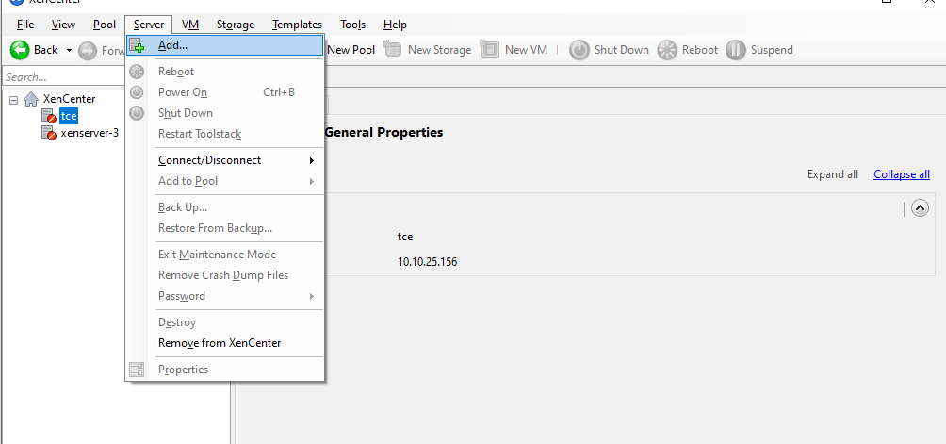

Steps 2:
Add the xenserver 1 by entering the Server , Username and password and click add.
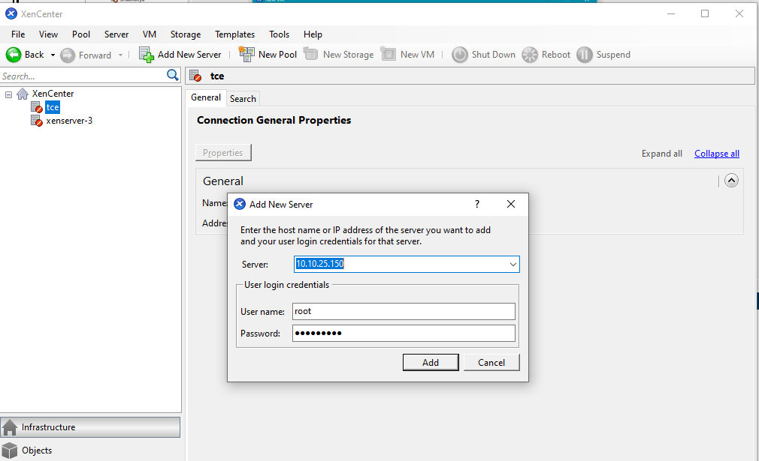
Steps 3:
Next add the vm of yours by clicking the xenserver 1 (right click) and add click new vm
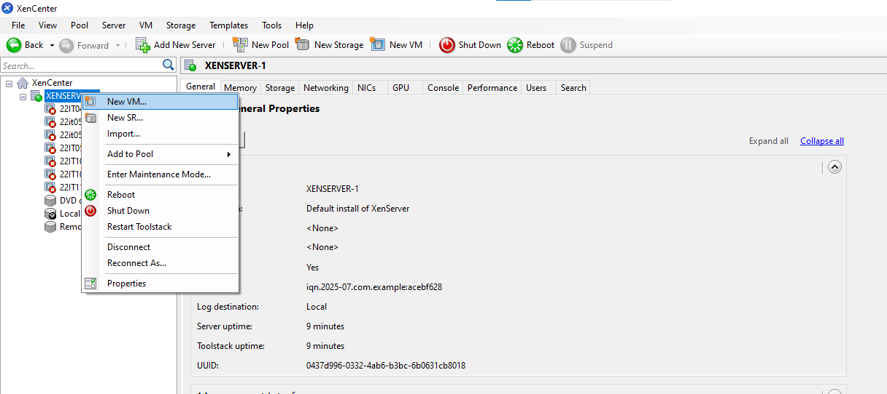

Steps 4:
Click the template example citric or ubunttu os or cent os(os which you have).
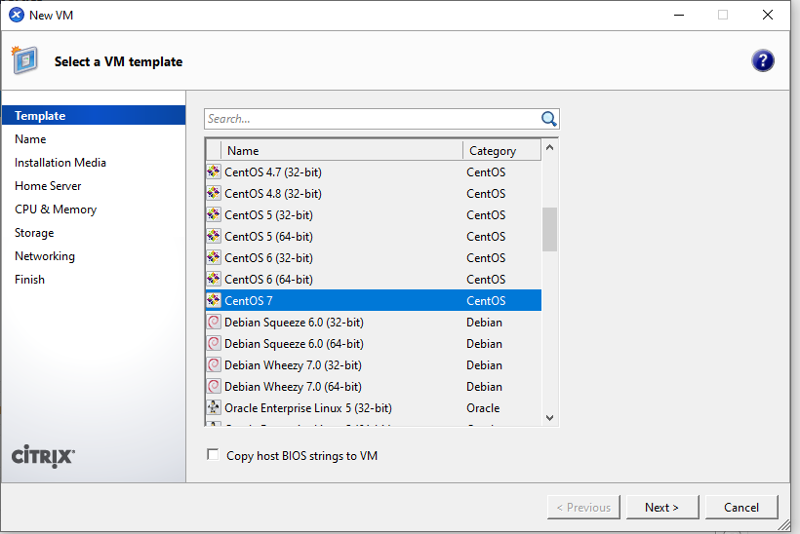
Steps 5: Give the name for your Vm and click next.
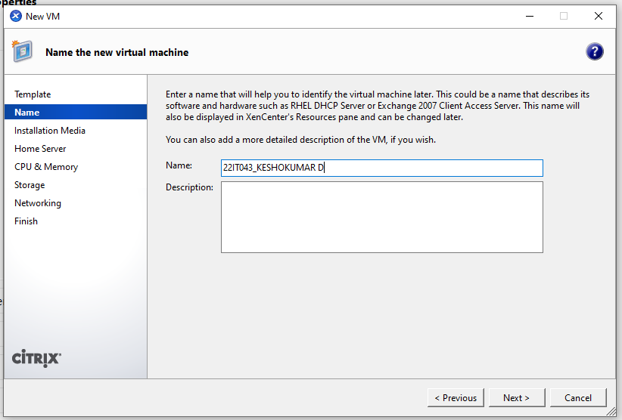
Steps 6: Select the iso file inside and click the next
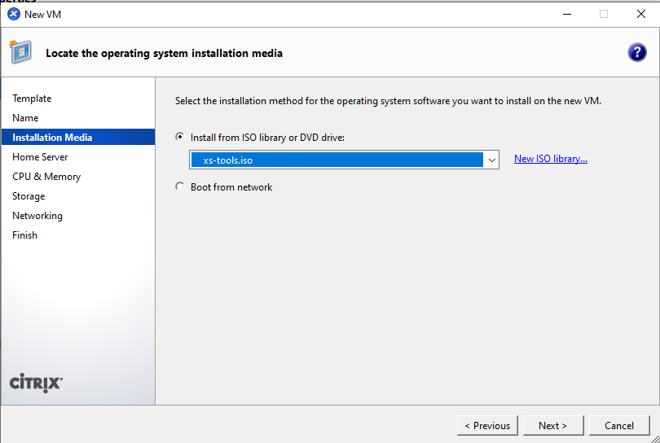
Steps 7:
Finally click the create now option then your vm has been created successfully.
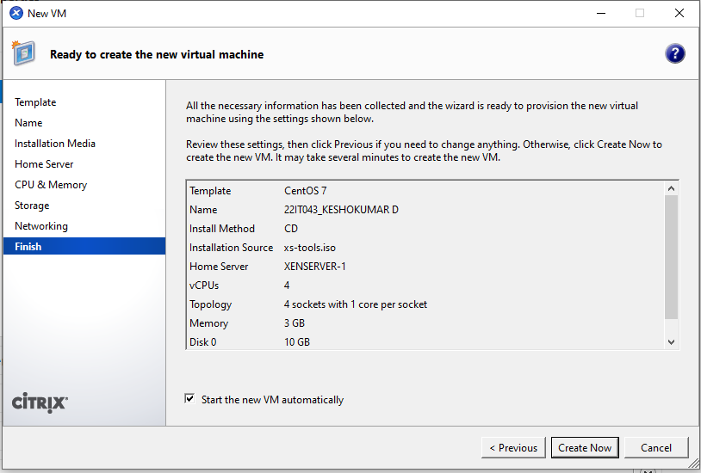
Steps 8: Create a xenserver 2 same procedure followed in first xenserver1 and click the xenserver 1.
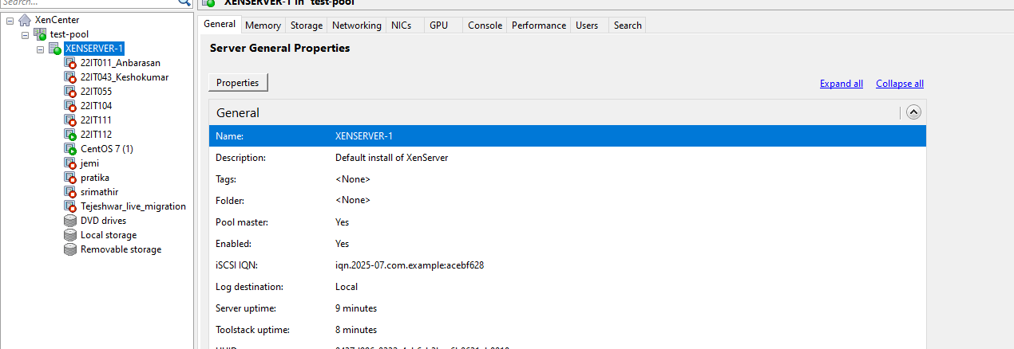
Steps 9:
Right click the vm and select the move vm option from the following
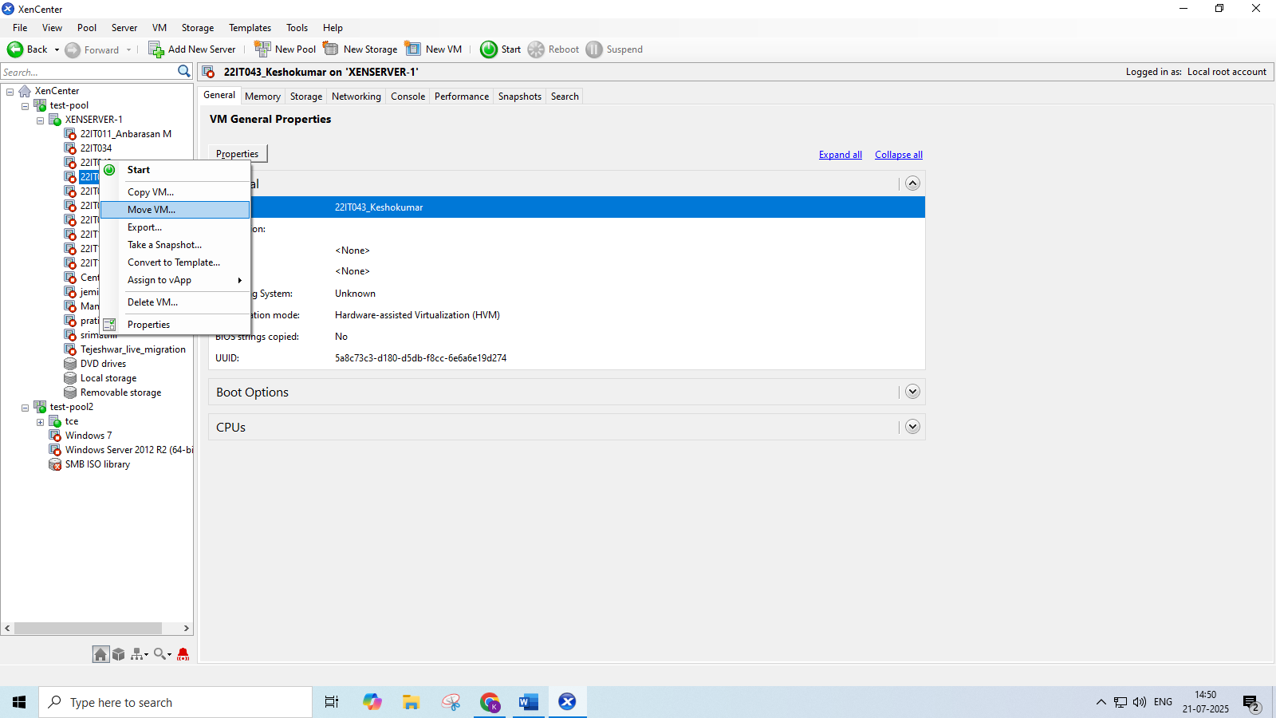
Steps 10: Select the xenserver 2 from the following list
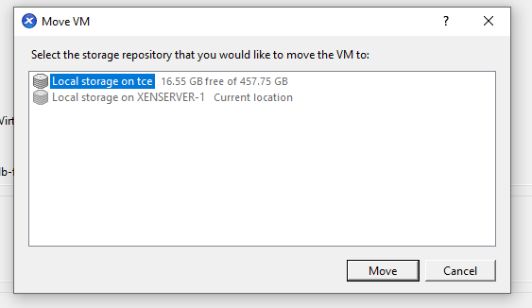
Steps 11:
Now see the Vm in the second server tce and the live migration has been executed successfully.

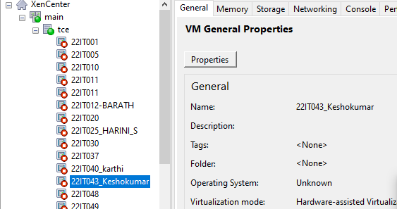

RESULT:
Successfully executed the setup of XenServer and XenCenter; live migration was performed and output verified with zero downtime during VM transfer.

Ex.no:5
5a) Installation of KVM and creation of Virtual instances

Aim:
To install a KVM and creation of virtual instance for setting up a virtualized environment on linux system.
What is KVM?
KVM (Kernel-based Virtual Machine) is an open-source virtualization technology built into the Linux kernel. It turns Linux into a type-1 hypervisor that allows you to run multiple virtual machines (VMs) on a physical host.
Each VM has its own virtual hardware (CPU, RAM, disk, etc.), and runs its own full-fledged operating system.
Benefits of KVM
Feature | Benefit
Open Source | Free and supported by the Linux community.
Performance | Near-native performance using hardware virtualization (Intel VT or AMD-V).
Security | Isolation between VMs using SELinux and AppArmor.
Scalability | Can handle many VMs on a single host (scales well vertically).
Flexibility | Supports many OSes (Linux, Windows, BSD, etc.).
Integration | Works with tools like libvirt, virt-manager, OpenStack, etc.
Live Migration | Supports live VM migration between hosts.
Procedure:
Virtualization Technology
- Check Hardware Virtualization Support.
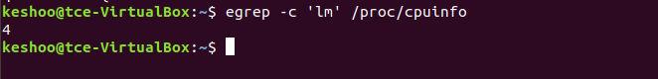Output ≥ 1 indicates support. If 0, CPU doesn't support hardware virtualization.
- Run uname -a , which shows kernel name, hostname, kernel version, build date, architecture, and OS type in one line.
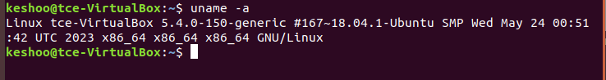
- To list the KVM kernel module files present in your kernel, run:
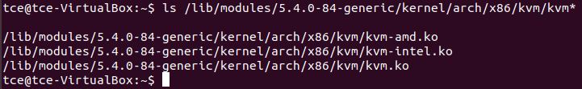

KVM Installation
- Install required packages : qemu-kvm, libvirt-bin, bridge-utils, virt-manager and qemu-system.
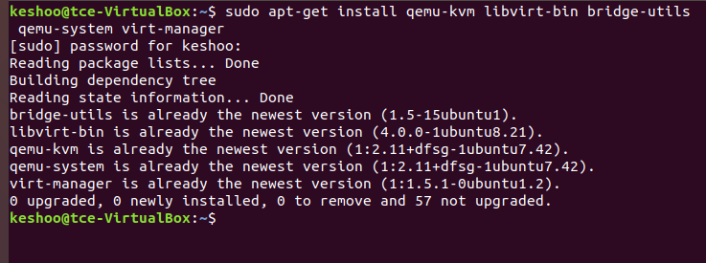
- Configure the libvirt daemon configuration file for remote access & socket permissions in KVM/libvirt
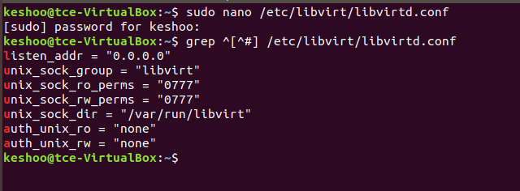

After configuring it, restart libvirtd dervice.
- Run virsh list - Displays no of Virtual machine running.
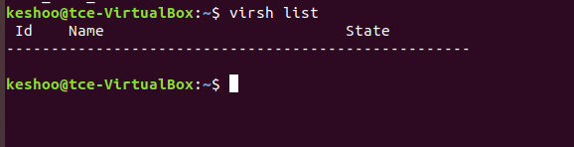
- Connecting to Virtualization interactive terminal.
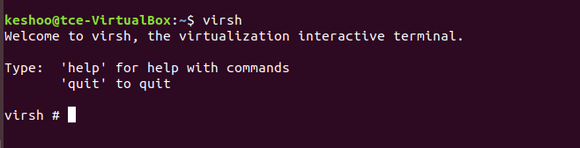
- Getting Version of libvirt & QEMU.
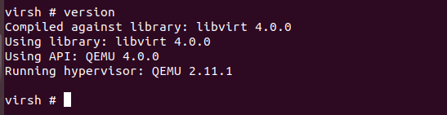
- Getting Node information
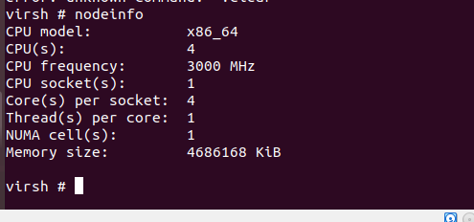
Importing existing VM
- Go to virtual machine manager (virt-manager) in your linux system. Then, right click QEMU/KVM and select New to create new VM.
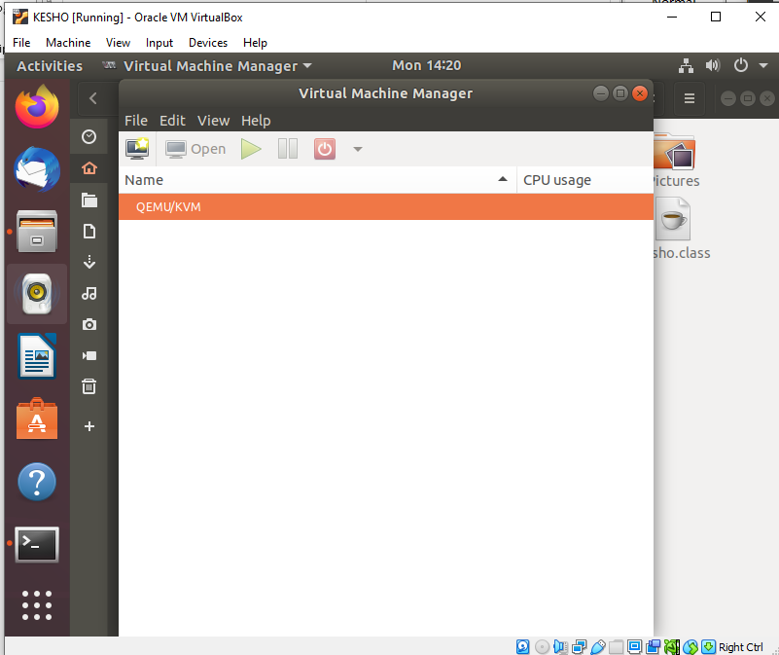

- Select import existing disk image and click forward.

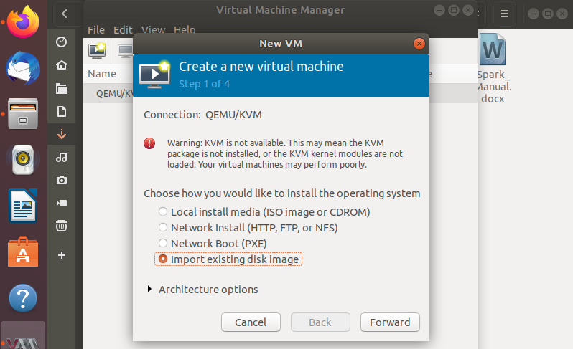

- Download cirros disk image from the link: https://download.cirros-cloud.net/0.5.1/
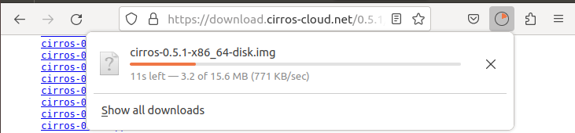
4.Give the path of downloaded cirros disk image and click forward.
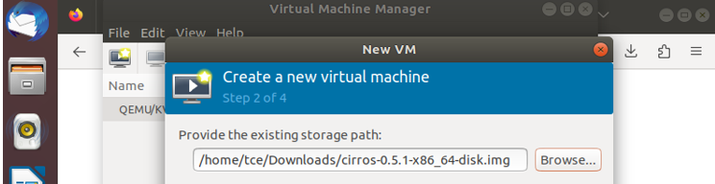

5. Choose memory and CPU settings and click forward.
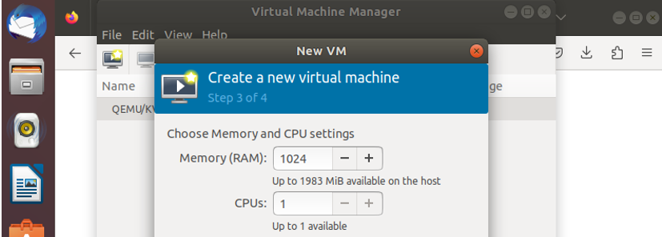
6.Name your VM and click Finish.
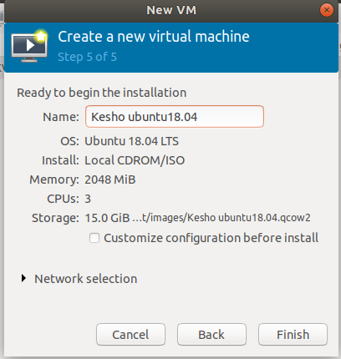

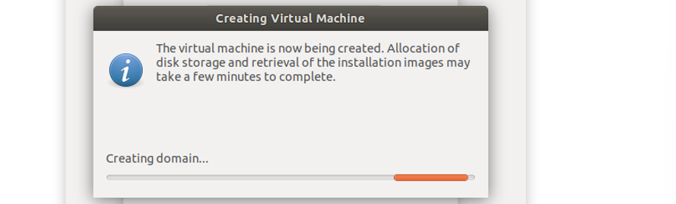

7.The VM is booted successfully and the login was also successful.
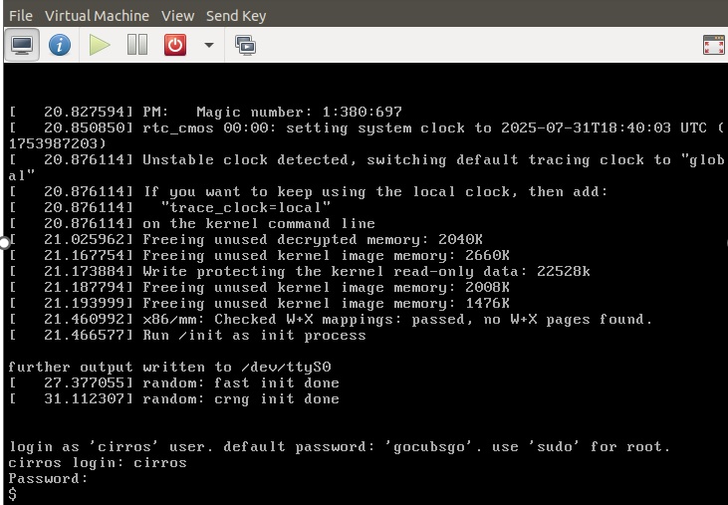

Result:
Thus, the KVM was successfully installed on the Linux system, and virtual instances were created and configured using Virt-Manager, demonstrating the setup of a virtualized environment.
5b) KVM – Create Images from ISO, Image Resizing, and Image Conversion

Aim:
To understand and demonstrate how to create virtual machine images using ISO files, resize virtual disk images, and convert disk images between various formats.

Procedure:
Creating VM image from ISO
- Go to virtual machine manager (virt-manager) in your linux system. Then, right click QEMU/KVM and select New to create new VM.

- Select Local install media (ISO image or CDOM).

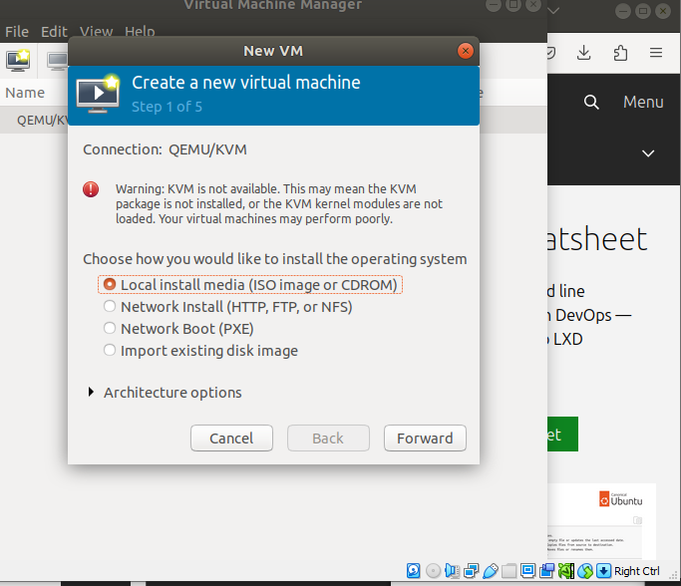

- Download ubuntu server iso from the link: https://releases.ubuntu.com/16.04/

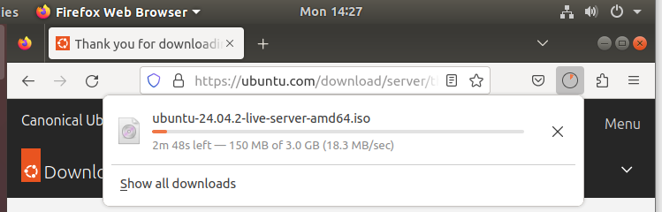

4.Select the downloaded ubuntu server iso path and click Forward.

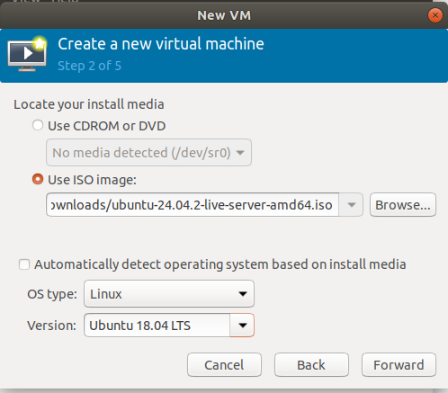

5.Specify the memory and CPU required and click Forward.

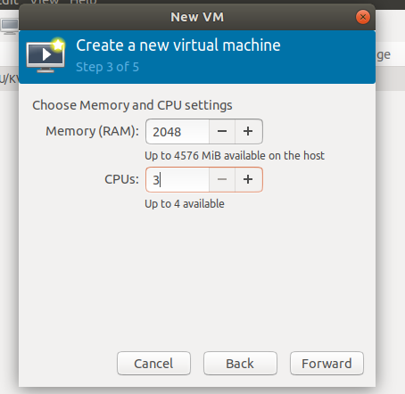

6.Run the command : qemu-img create -f qcow2 ubuntu_vm.qcow2 10G

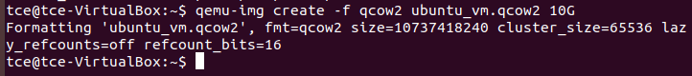

This command creates a virtual hard disk file (ubuntu_vm.qcow2) in the QCOW2 format, with a maximum size of 10 GB. This file will act as the virtual disk for a KVM virtual machine.

7.Name the VM and click Finish.

8.Select the language.

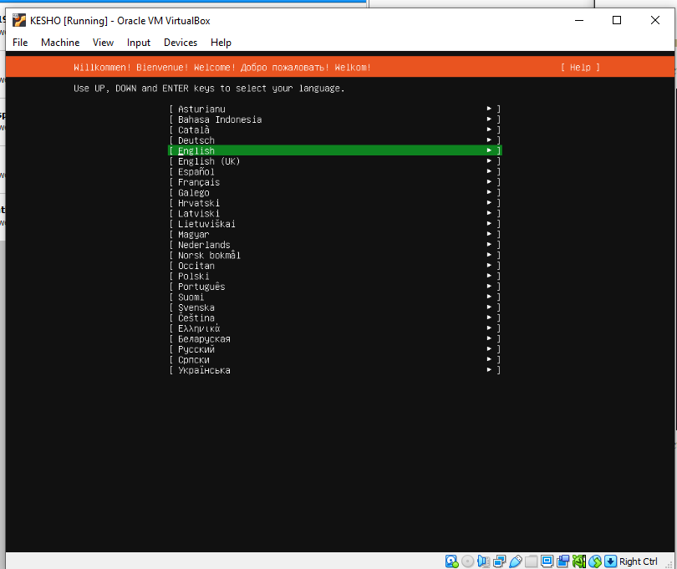

9.Select Install Ubuntu Server and then the VM boots.
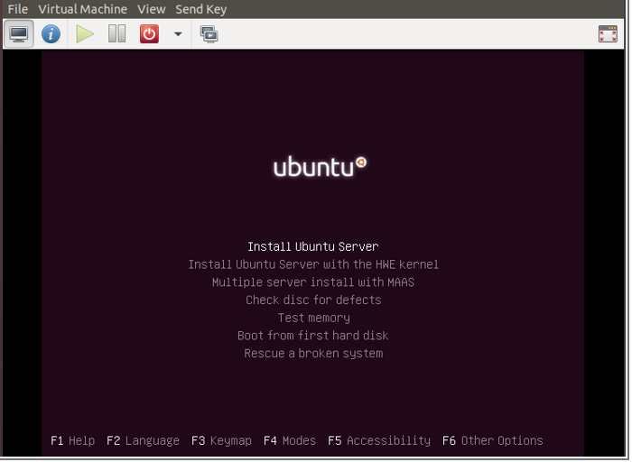

10. Select the language and location.
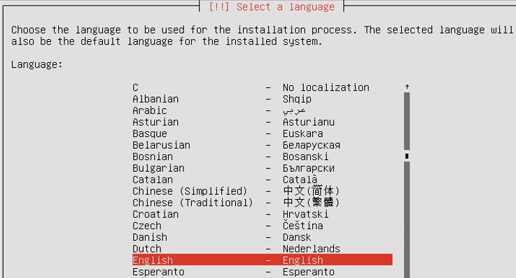

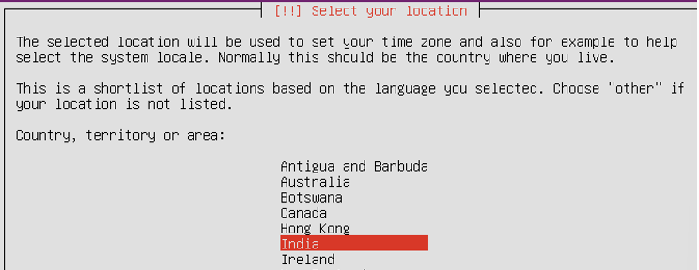

11.Set the Keyboard configuration.

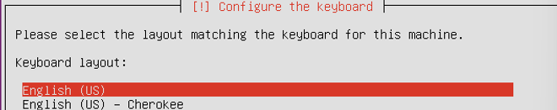
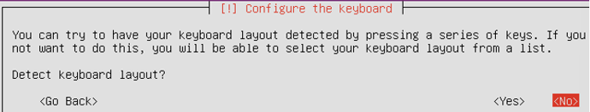

12.Then it starts detecting, loading and scanning of needed things.

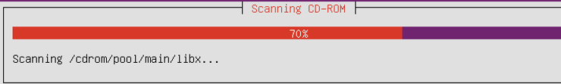

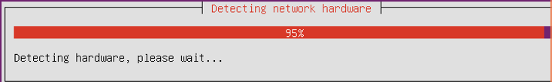

13.Then set hostname, username, password and clock settings.

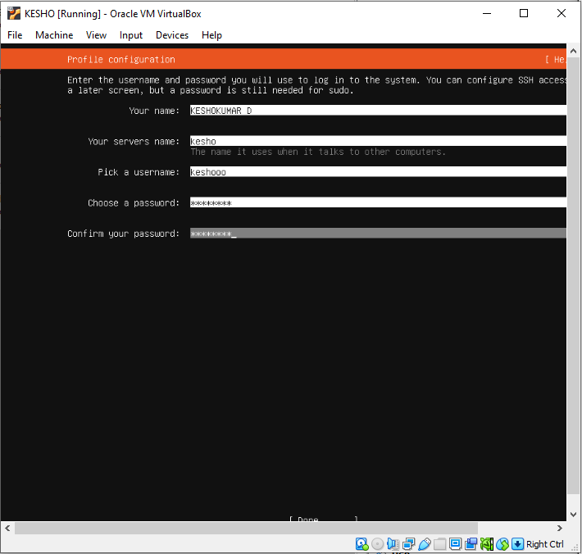

14.Set the disk partition.
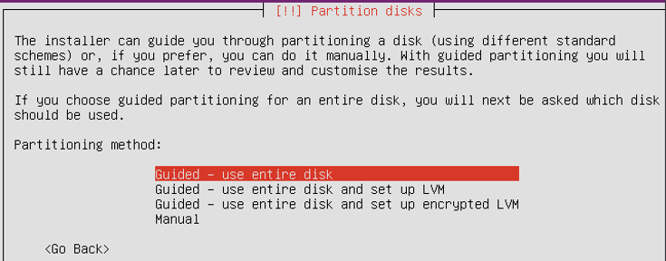

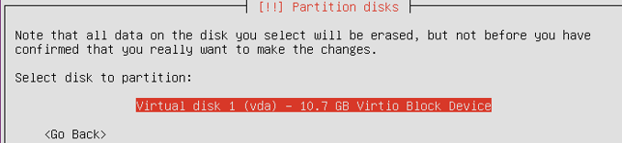

15.Select Yes to write the changes to disks.
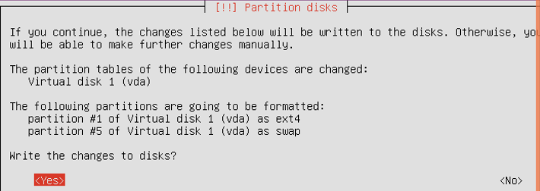

16.Then, the system installation starts.

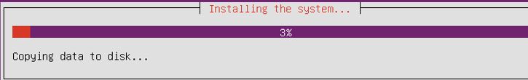
17.For http proxy, just click Enter.
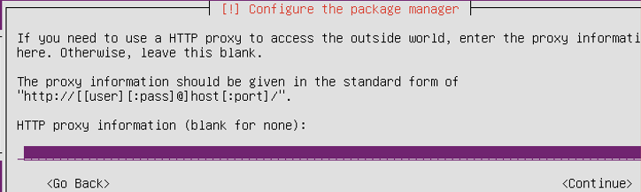

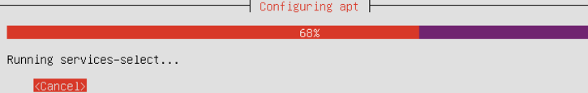

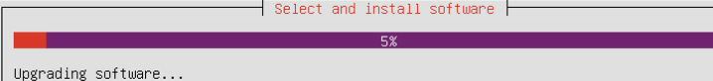

18.Select No automatic updates option for configuring tasksel.
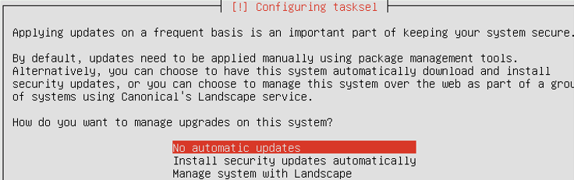

19. In Software selection, select(use Spacebar) standard system utilities and OpenSSH server.
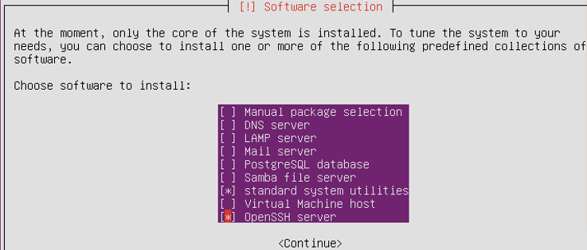

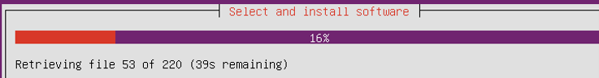

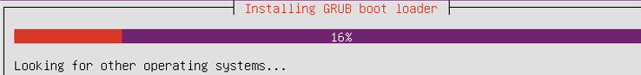

20.Give Yes to install GRUB boot loader.

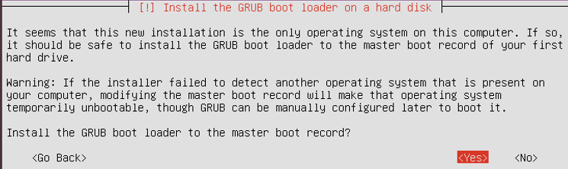
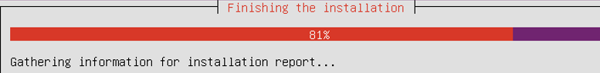

21.Now, login to your VM.
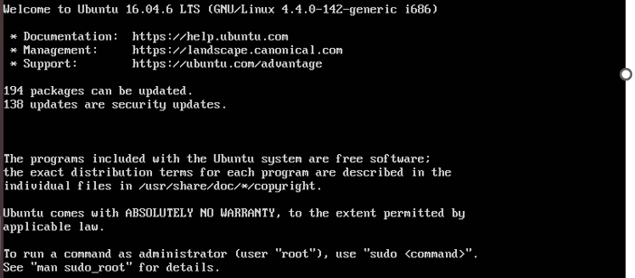
Image Resizing

- Shut down the VM if it's running.
- Resize the qcow2 image.
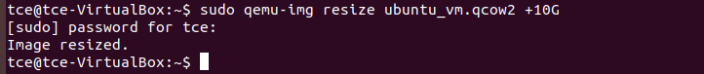
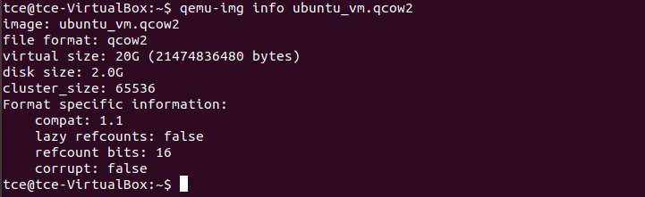
- Resize partitions inside the VM.
Once you've resized the image, boot into the VM and resize the partition/filesystem:
sudo growpart /dev/sda 1
sudo resize2fs /dev/sda1

Image Conversion
- Conversion of qcow2 to vhd, vdi using qemu-img.
qcow2 to vdi
qcow2 to vhd
qcow2 to img

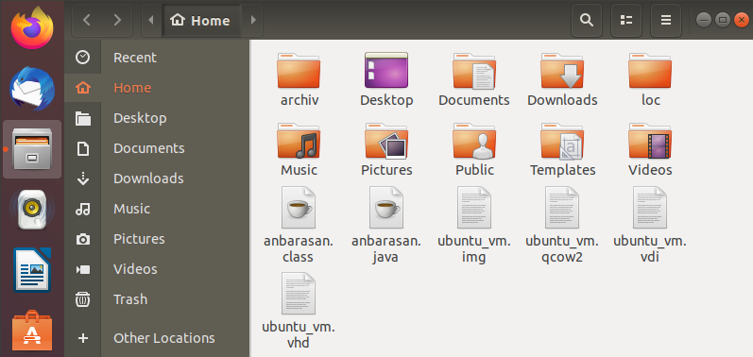

Result:
Thus, the creation, resizing, and format conversion of a KVM virtual disk image were successfully demonstrated.
Ex.no:6
6.Transfer of files from one Virtual Machine to another
Aim:
To transfer files from Ubuntu VM to Kali VM using NFS share, enabling read and write access on both ends.
Steps:
1.Configure VirtualBox Network
Set both VMs’ network adapter to "Host-only Adapter” in adapter 1 and NAT in adapter 2(for installing packages) so they are on the same subnet.
Go to settings -> network -> adapter 1-> Host only adapter and Adapter2-> NAT
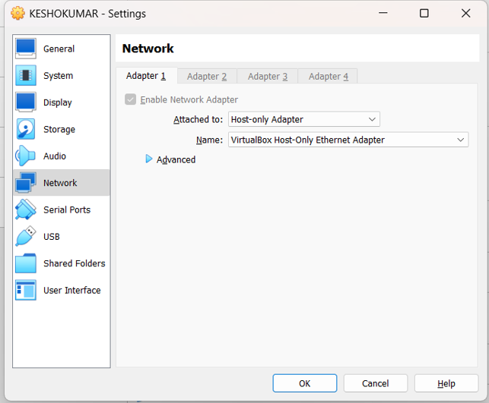
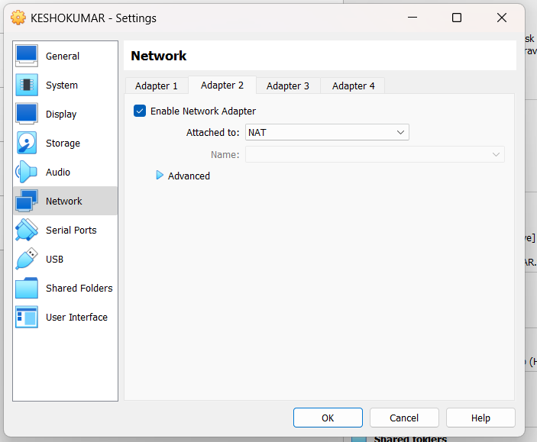
2. Check IP Addresses
On both ubuntu as well as kali ip a (check ip) Ensure both are in same subnet (eg 192.168.56.103/24 ubunttu and 192.168.56.104 kali) both in same subnet 192.168.56.0/24
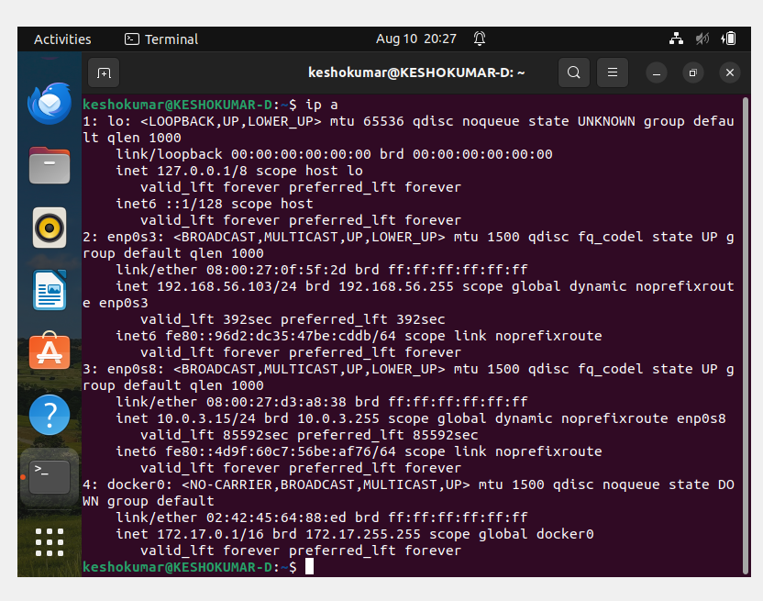
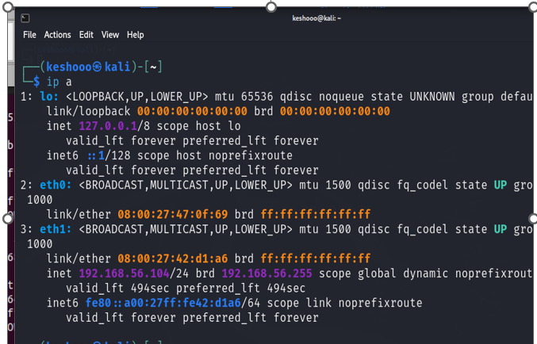

3. Set up NFS Server on Ubuntu VM(Here ubuntu act as server)
- Sudo apt update
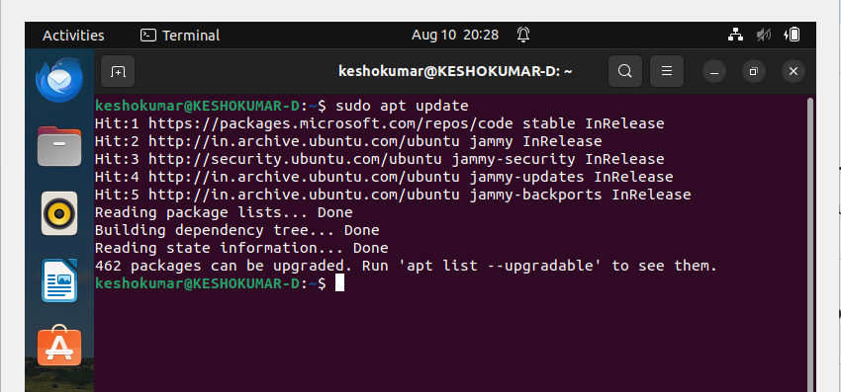
- Update and install NFS server:
sudo apt update
sudo apt install nfs-kernel-server -y
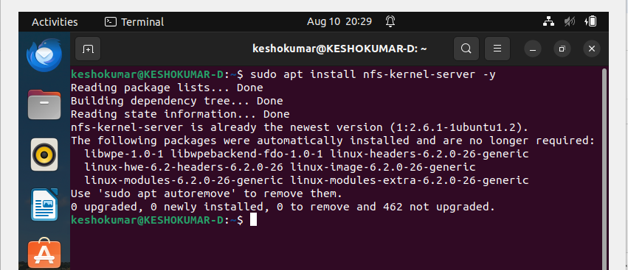

- Create folder to share:
sudo mkdir -p /srv/nfs/sharedfolder (or any folder name)
- Set permissions:
  - sudo chown nobody:nogroup /srv/nfs/sharedfolder
  - sudo chmod 777 /srv/nfs/sharedfolder
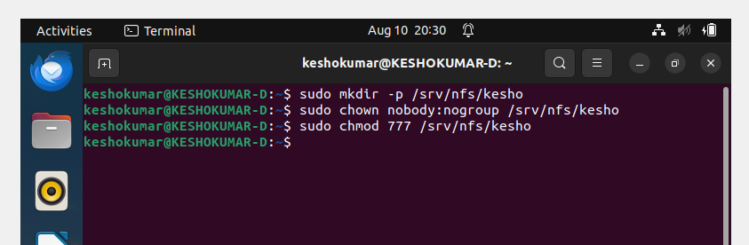
- Edit exports file to allow Kali IP access:
sudo nano /etc/exports (it open in nano editor)
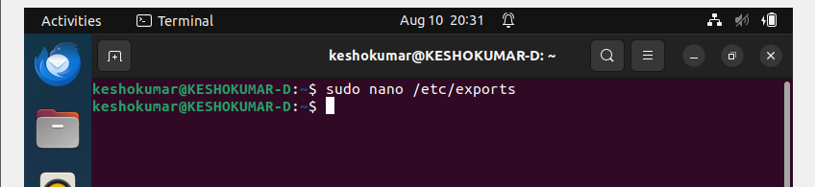
Add /srv/nfs/sharedfolder < kali ip >(rw,sync,no_subtree_check,no_root_squash)
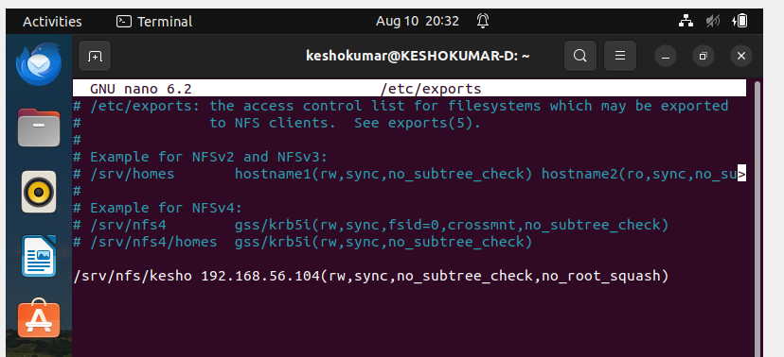
Click ctrl+o and enter and ctrl x ( to save and came out of nano editor)
- Export and restart NFS server:
sudo exportfs -a
sudo systemctl restart nfs-kernel-server
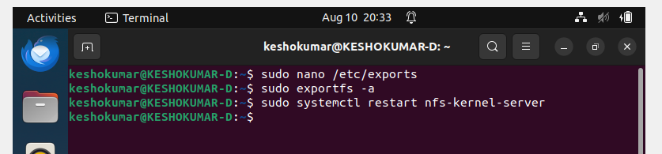
- Allow/disable the firewall for the kali linux (skipping shown already firewall in disable mode)
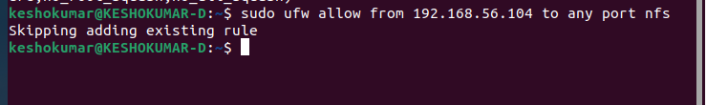

4. Set up NFS Client on Kali VM
- Install NFS client:
  - sudo apt update
  - sudo apt install nfs-common -y
(here apt update not work because of network is in off so go to wired connection top right corner change the wired connection(NAT) and after above two command change again the wired connection1(Host only adapter)
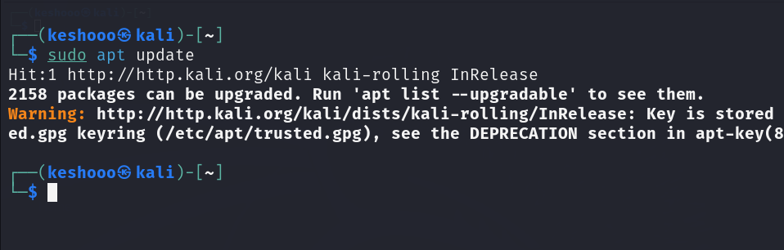
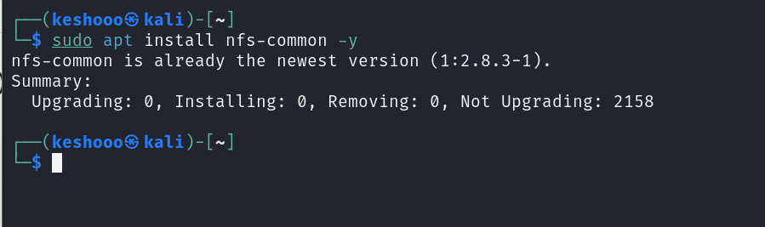
- Create mount point:
sudo mkdir -p /mnt/nfs/sharedfolder
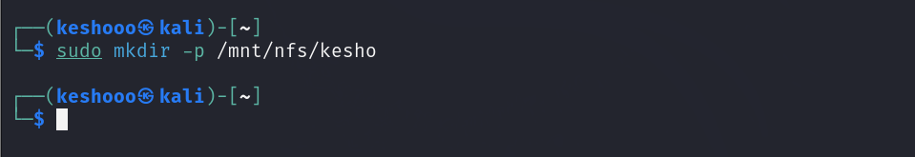
- Mount the NFS share:
sudo mount ubuntu ip:/srv/nfs/dir _name /mnt/nfs/dir_name
eg:
sudo mount 192.168.56.103:/srv/nfs/sharedfolder /mnt/nfs/sharedfolder
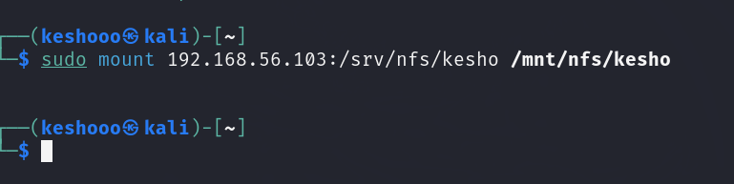
- Verify:
df -h | grep nfs
ls -l /mnt/nfs/sharedfolder
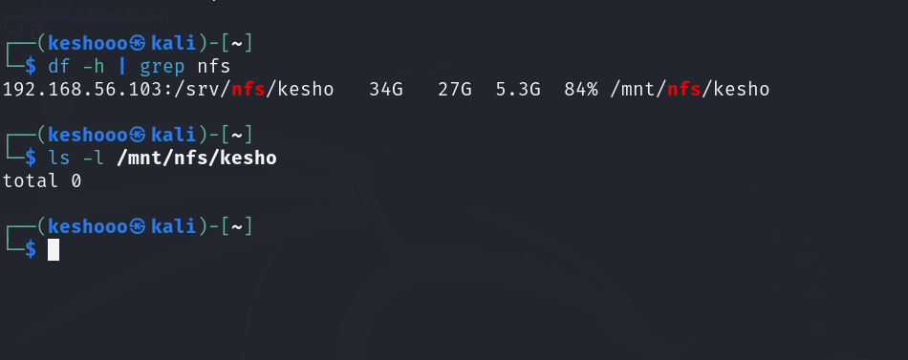

5. Test File Transfer
- On Ubuntu VM, create file:
echo "Hello from Ubuntu" | sudo tee /srv/nfs/dir_name/ubuntu_test.txt
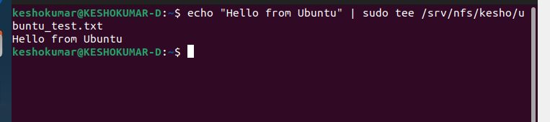
- On Kali VM, verify(READ OPERATION)
ls -l /mnt/nfs/sharedfolder
cat /mnt/nfs/sharedfolder/ubuntu_test.txt

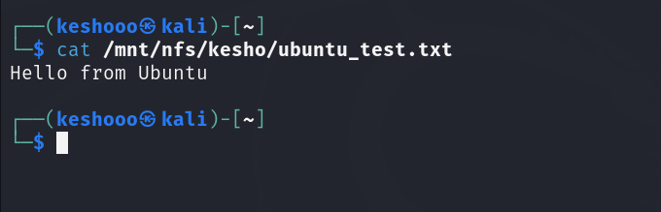

- On Kali VM, (WRITE OPERATION):
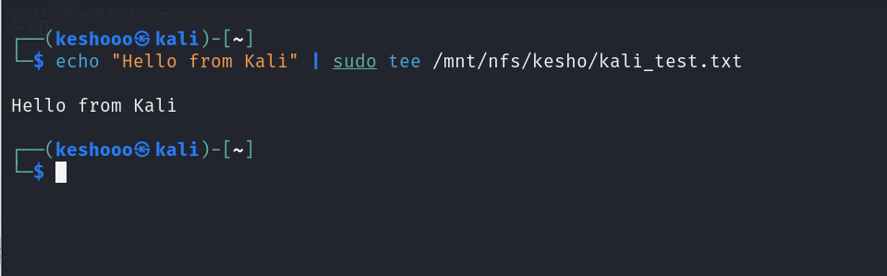
- On Ubuntu VM, verify
ls -l /srv/nfs/sharedfolder
cat /srv/nfs/sharedfolder/kali_test.txt

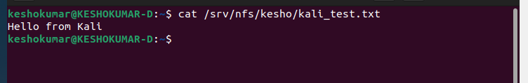

METHOD 2
SHARED FOLDER
Step 1: Create a Shared Folder on Your Host
- On your host machine (Windows/Linux):
  - Create a folder, e.g., C:\VMShared

  - Add a test file (22IT043.txt) to confirm later.
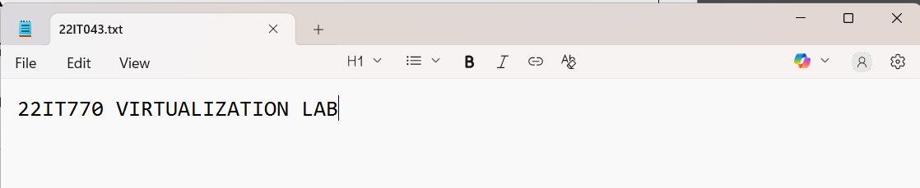
Step 2: Enable Shared Folder in VirtualBox (for Both VMs)
Repeat this for both Ubuntu VMs.
- Shut down the VM if it’s running.
- In VirtualBox Manager, select your VM.
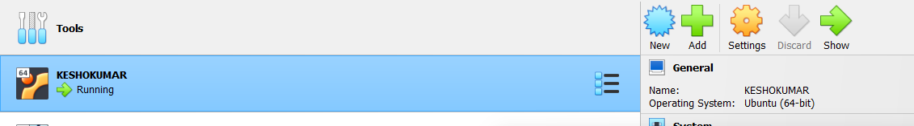
- Click Settings → Go to Shared Folders tab.
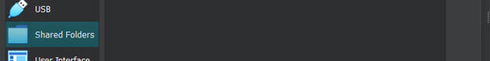

- Click “+” (Add new shared folder).
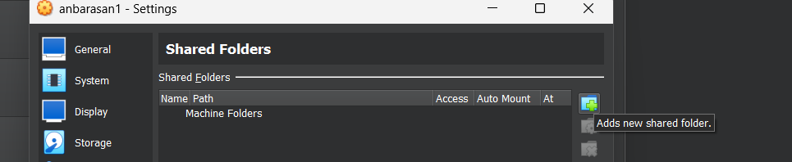
- Set:
  - Folder Path: Select C:\VMShared (or wherever you created it).
  - Folder Name: VMShared (updates once path is entered)
  - Check(Tick) Auto-mount
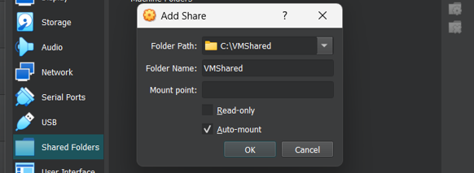
Click OK.
- Then, again Click OK (at bottom) to save.
Do this for both VMs
VM2:
3.In VirtualBox menu (inside VM window), go to: Devices → Insert Guest Additions CD image
VM1:
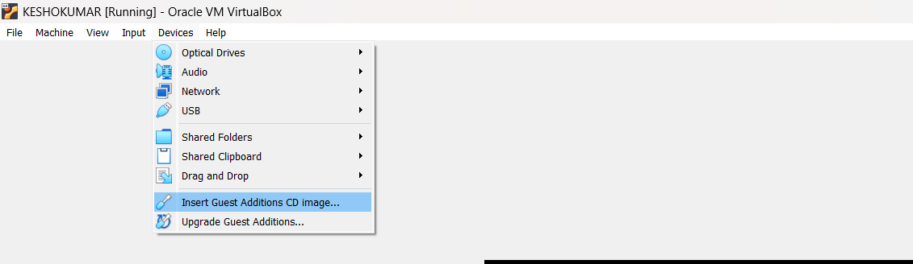

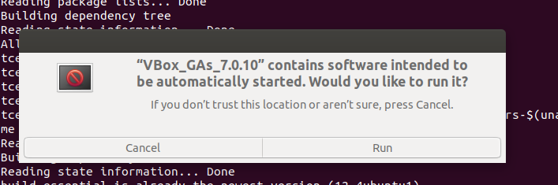

Now use the command: ls /media
- It lists all the directories (i.e., mounted devices or drives) under the /media directory.
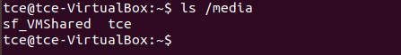
Therefore, in VM1 sf_VMShared folder is there in /media directory.
VM2: SAME PROCEDURE FOR virtualbox 2
Run the command: ls /media
Therefore, in VM2 also sf_VMShared folder is there in /media directory.
Step 4: Access the Shared Folder
After rebooting each VM, the shared folder should be mounted automatically at: /media/sf_VMShared
To check, run the command : ls /media
VM1 :
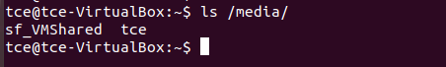
VM2 :
Run the command : ls /media/sf_VMShared
VM1 :
VM2 :
You should see the 22IT043.txt file from your host.
But in VM1 and VM2 , it asks for permission to list the files of sf_VMShared folder.
Step 5: Fix Permissions (if Permission Denied)
You need to add your user to the vboxsf group:
sudo usermod -aG vboxsf $USER
Then reboot again:
sudo reboot
Now try again:
ls /media/sf_VMShared``
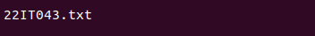
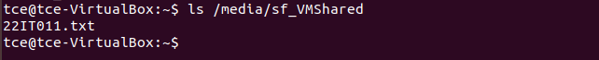
You should now have full access.
Step 6: Transfer Files Between VMs
- Trying to print the content of 22IT043.txt file from VM1

- Now in VM1, copy a file to /media/sf_VMShared folder,
cp VM1.txt /media/sf_VMShared/
- Switch to VM2, and check the shared folder:
ls /media/sf_VMShared
The VM1.txt file will appear — you can copy it out to any other location and also you can edit files in shared folder location itself. Any changes done in shared folder using one VM will also be reflected to the other VM.
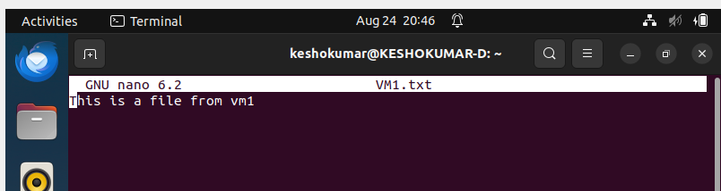
Also 22IT043.txt file is accessible in VM2,
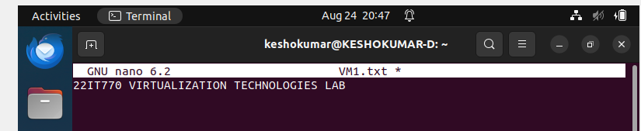

METHOD 3(SSH Secure Shell)
Step 1: Install SSH
On both VMs (VM1 & VM2):
sudo apt update
sudo apt install openssh-server -y
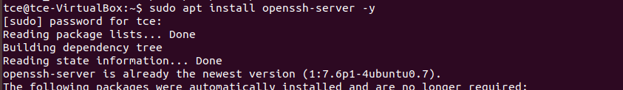
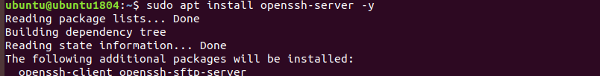
Check SSH status:
sudo systemctl status ssh
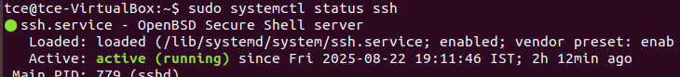
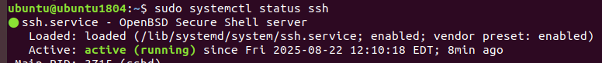
Step 2: Get Server’s IP
On VM1 (Server, username = tce):ip a
Allow firewall settings for SSH to avoid Connection timed out error.
sudo ufw allow 22/tcp
sudo ufw reload
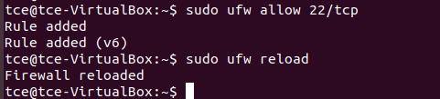
Step 3: Connect from VM2 to VM1
On VM2 (Client, username = ubuntu):
ssh tce@192.168.56.103
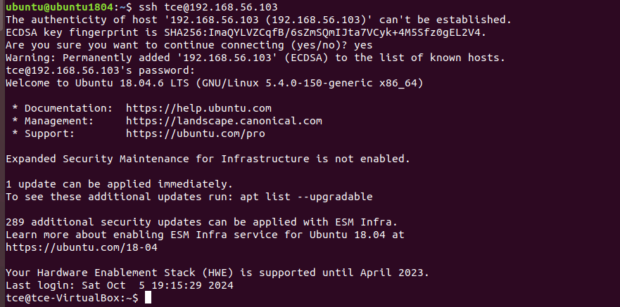Enter tce’s password → now you are logged into VM1.
Step 4: Transfer Files with SCP (From VM2)
(a) Copy file from VM2 → VM1
scp file.txt tce@192.168.56.103:/home/tce/
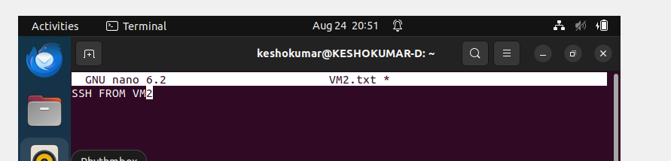

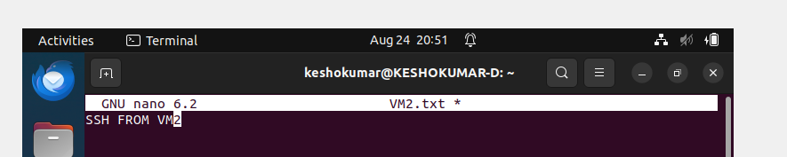
(b) Copy file from VM1 → VM2
scp tce@192.168.56.103:/home/tce/serverfile.txt /home/ubuntu/
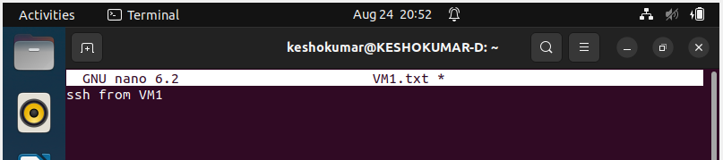
METHOD 4(FTP (File Transfer Protocol)
Step 1: Install FTP Server on VM1
(VM1 = server, VM2 = client)
On VM1:
sudo apt update

sudo apt install vsftpd -y
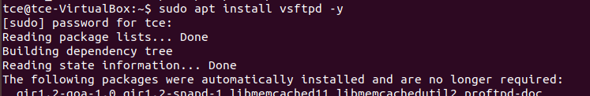
Enable and start the service:
sudo systemctl enable vsftpd
sudo systemctl start vsftpd
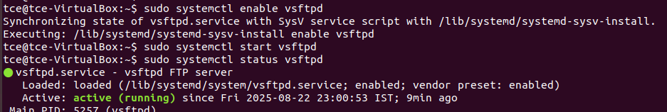
Step 2: Configure vsftpd
Edit the config file:
sudo nano /etc/vsftpd.conf
Make sure these lines are set (uncomment or add if missing):
local_enable=YES
write_enable=YES
chroot_local_user=YES
allow_writeable_chroot=YES
Save (CTRL+S, CTRL+X)
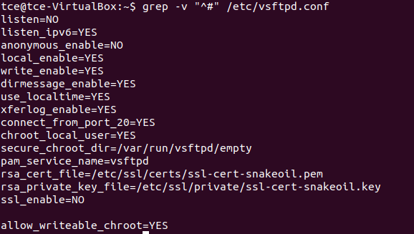
Restart the ftp server:
sudo systemctl restart vsftpd
Step 3: Check VM1 IP Address
On VM1, run:
ip a
Allow firewall settings for FTP to avoid Connection timed out error.
sudo ufw allow 21/tcp
sudo ufw allow 20/tcp # (for data transfer)
sudo ufw status
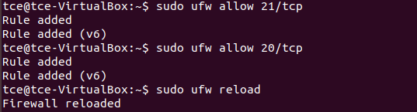

Step 4: Connect from VM2 (FTP client)
On VM2, install ftp client:
sudo apt install ftp -y
Now connect:
ftp 192.168.56.103
Enter VM1’s username (tce) and password when prompted.
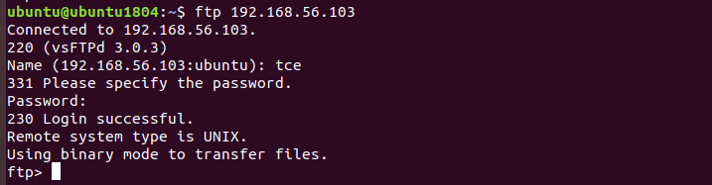
Step 5: FTP Commands
Once connected, you can use:
- ls → list files on VM1
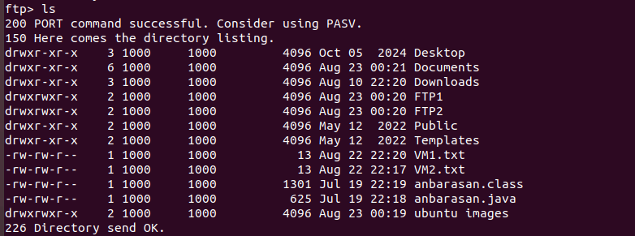
- cd folder → change directory on VM1
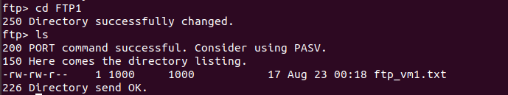
- get filename → download file from VM1 → VM2
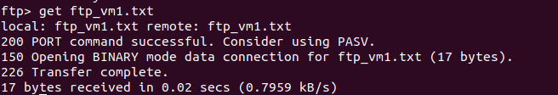
- put filename → upload file from VM2 → VM1
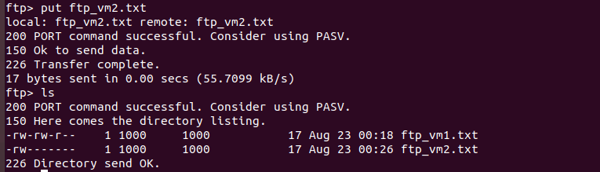
- bye → exit
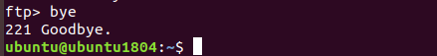
Step 6: Verify
- ftp_vm1.txt should now be in VM2’s current directory.
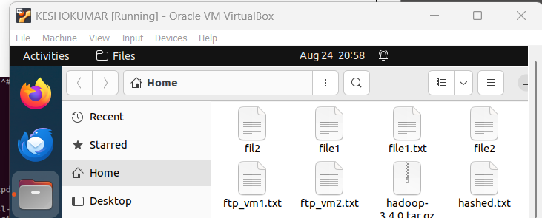

- ftp_vm2.txt should now be uploaded to VM1’s /home/FTP1/ directory.
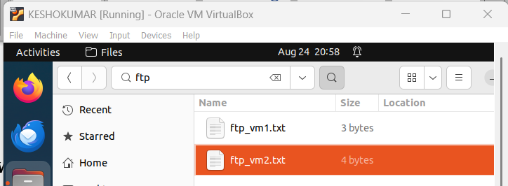

RESULT:
Thus the file transfer between Ubuntu and Kali VMs is executed successfully and both VMs can read and write files in the shared folder seamlessly.

Ex.no:7
7a) Configuration of HyperV on Windows of VMs
Aim:
To configure Hyper-V on Windows for creating and managing virtual machines (VMs), enabling efficient virtualization and resource utilization.
Steps:
1)Open the windows server and open the server manager Click add roles and features . Read before you begin and click next.
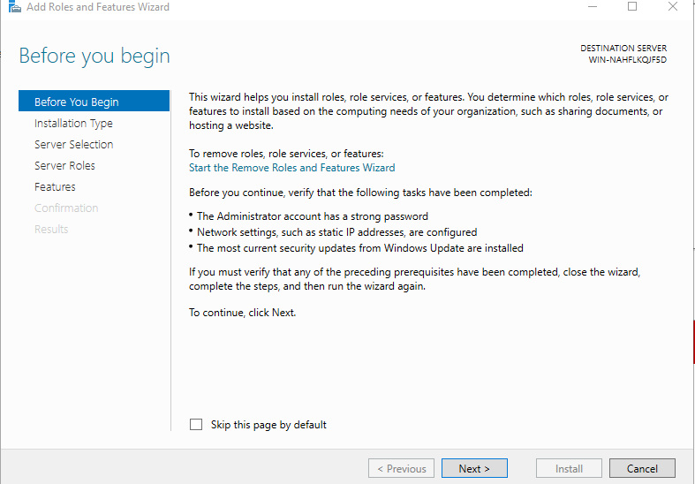
2) Select role based installation type and click next.
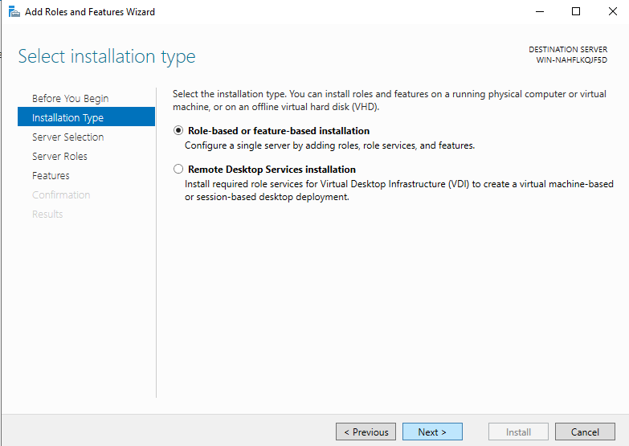

3)Select the server and click next
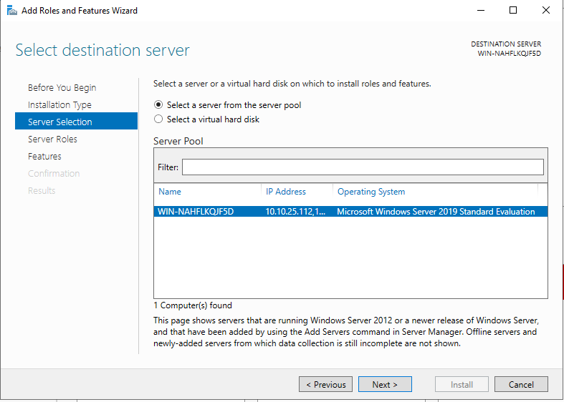
4) In server roles .check on hyper v and click the add features .
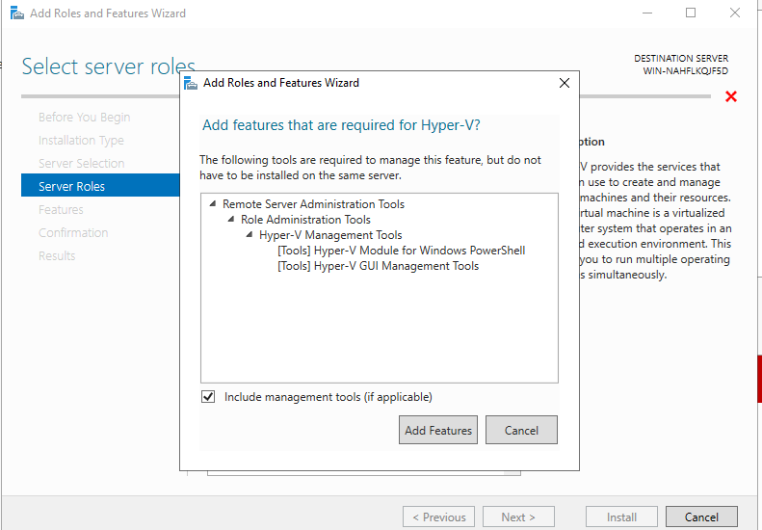

5) Enable virtual switches both ethernet and virtual box host only adapter
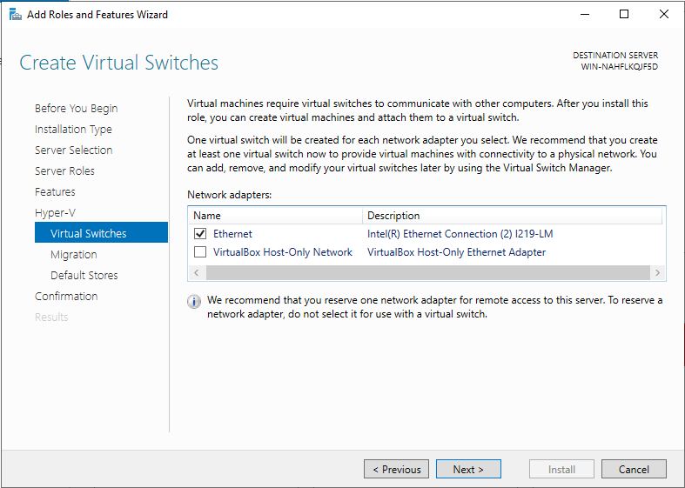

6) For migration use credential security support provider
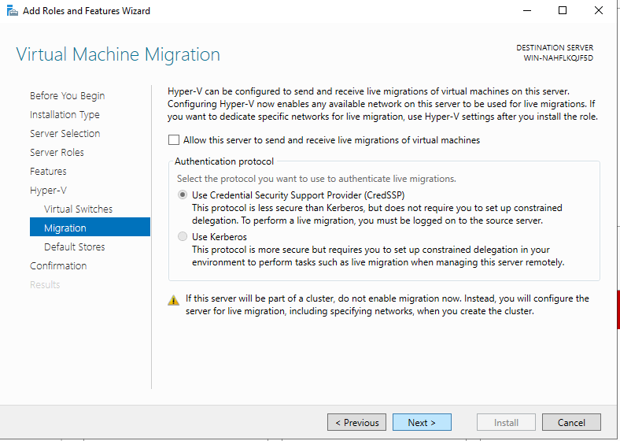

7) Click install and hyperv has been installed and enabled on the windows server
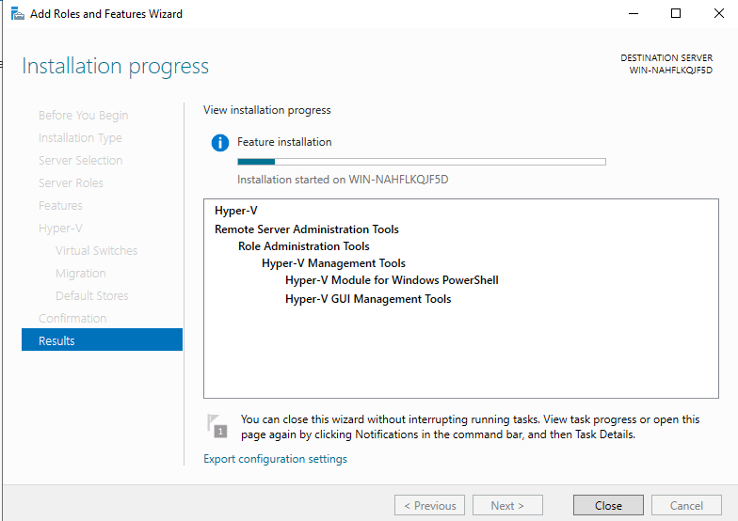
8)Open hyperv manager in tools
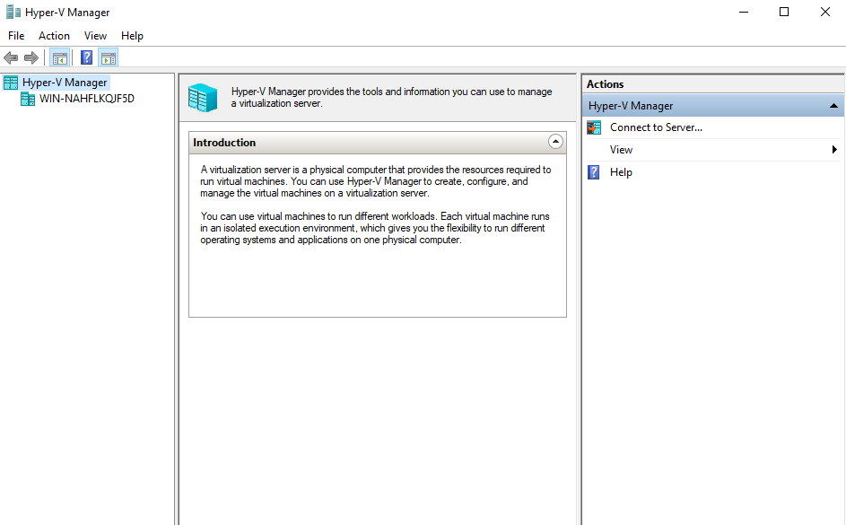

RESULT:
Thus the configuration Hyper-V on Windows for creating and managing virtual machines (VMs), enabling efficient virtualization and resource utilization has been executed successfully.
7b) Creation of VM, Powershell commands, Management
Aim:
To create and manage Virtual Machines (VMs) using Hyper-V, including PowerShell commands for automation and efficient administration.
Procedure:
(Vm installation without powershell)
1)open Tools-> hyper v manager-> right click on server and click create new vm
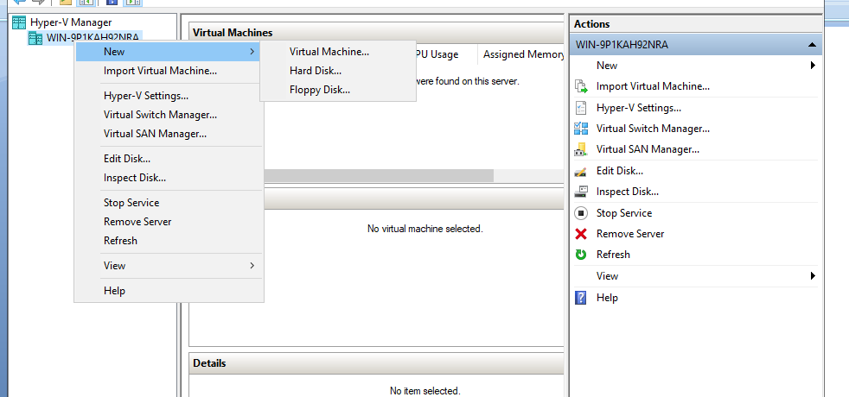
2)Specify name and location click next.
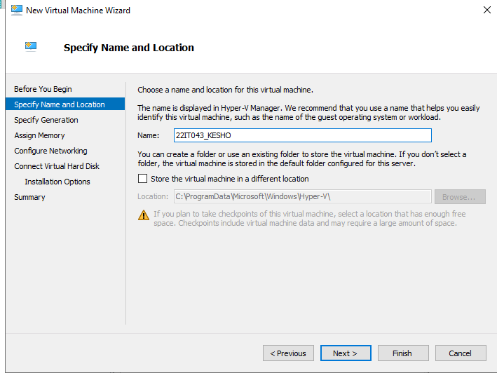
3)Assign the memory for the vm(for safety give as 2gb )
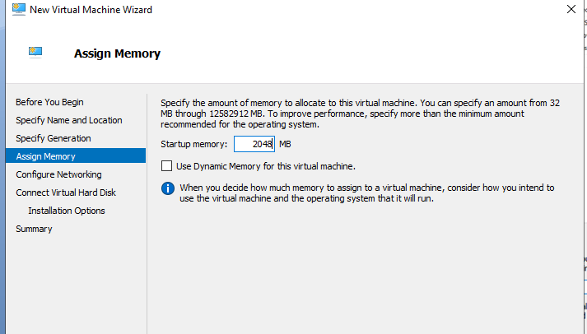
4)Conigure the network click on interR Ethernet connection virtual switch
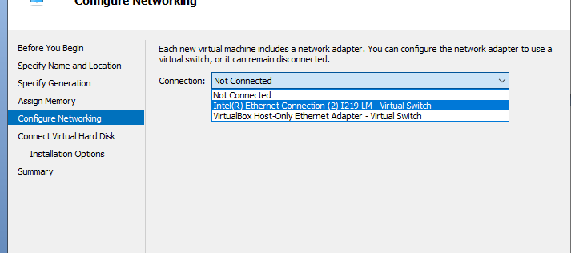
5)Connect virtual harddisk (name,location,maximum gb) click next
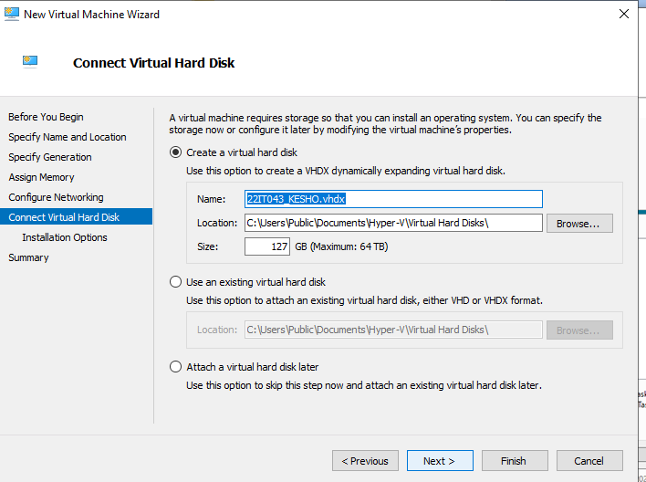
6)Import the iso file which os need to install on the vm(here ubunttu)
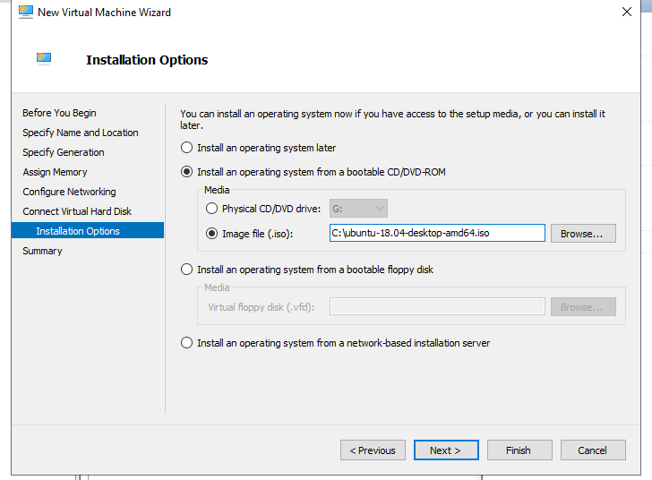
7)Click finish
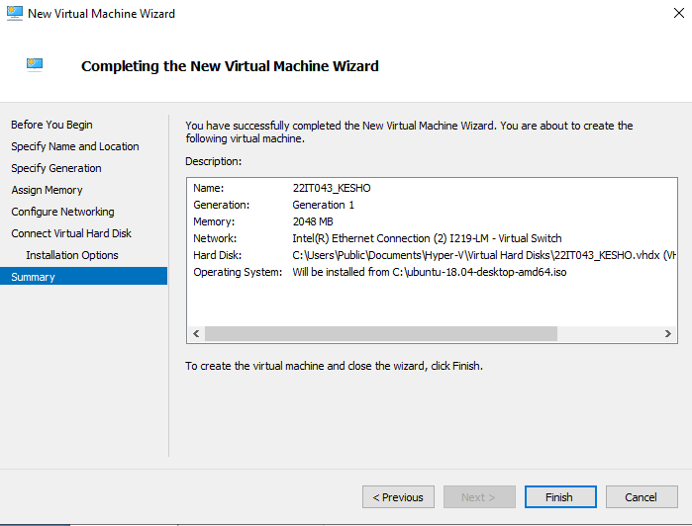
Vm installation using Powershell Procedure :
- Create vm with name and space in gb with virtual hard disk creation
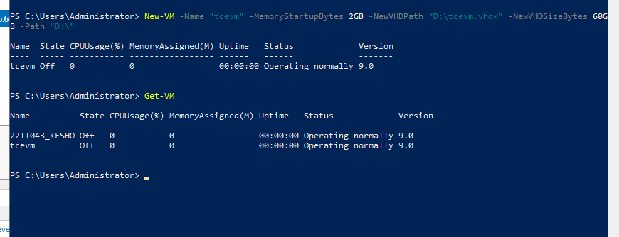
2)Asssign virtual switch to the vm
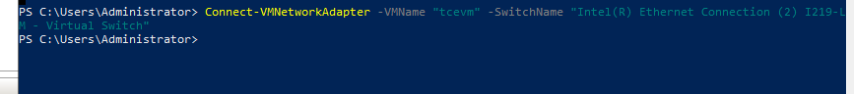
3)import the iso file which os need to install on vm
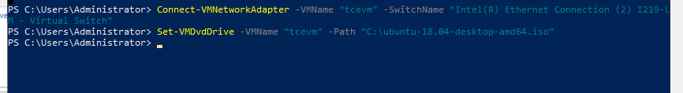
4)Start the vm
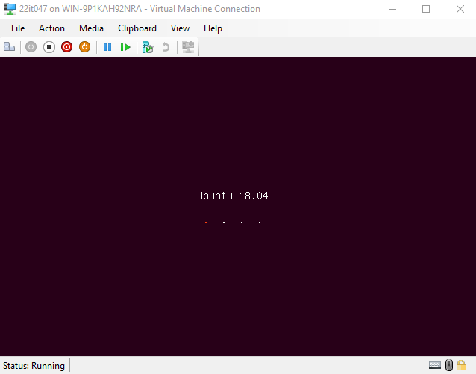
Powershell commands
1)Get vm and start vm
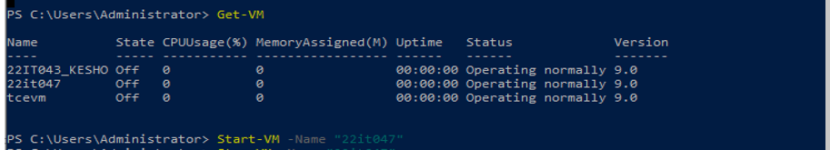
2)Stop vm
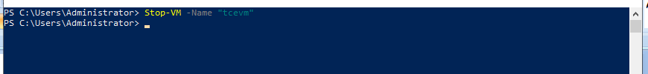
Migration(Right click the vm and click move) and give finish .
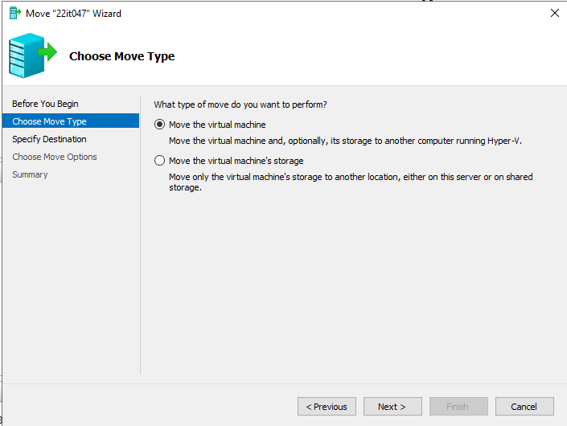
Result:
Thus the creation and manage Virtual Machines (VMs) using Hyper-V, including PowerShell commands for automation and efficient administration has been executed successfully.

Ex.no:8
8) Installation of OpenStack and creation of Virtual machines
Aim:
To install of openstack and creation of virtual machine in linux system.
Steps:
1)Update all the file in the ubunttu by sudo apt update
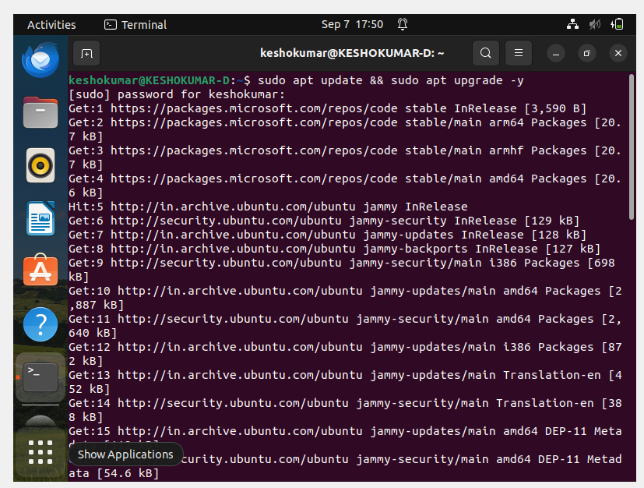
2)Install the packages to build the openstack
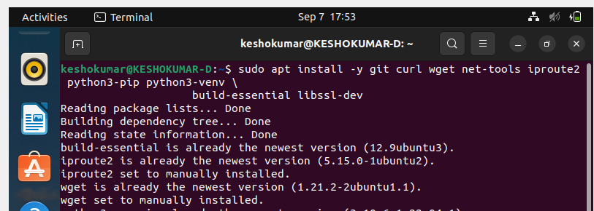
3) Add the user stack to the ubunttu especially for the openstack and give the sudo privilege for the user stack and add to the group
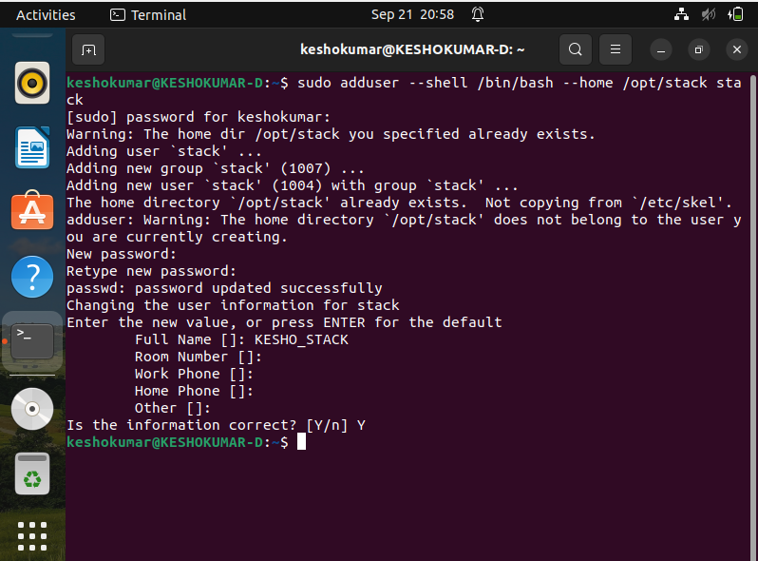
4) Set no password for all
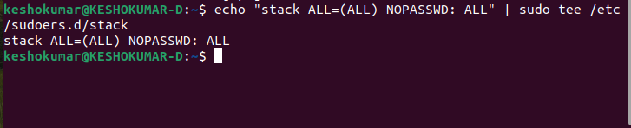
5)Give the privileges for the user stack
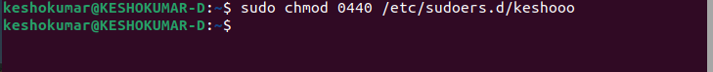

6) open the keshoo as sudo user by the command sudo su - stack
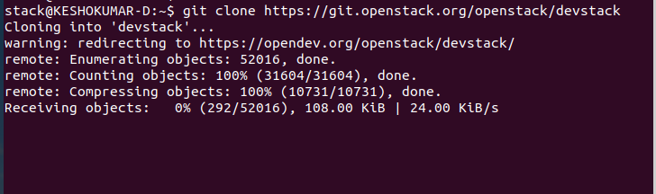
7)go to home directory and download the openstack from the git by cloning the git .
8) Move to the devstack directory
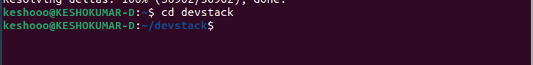
9)Change the configuration file in the local.conf
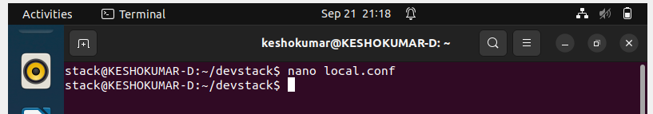

Update the below line and give password for each
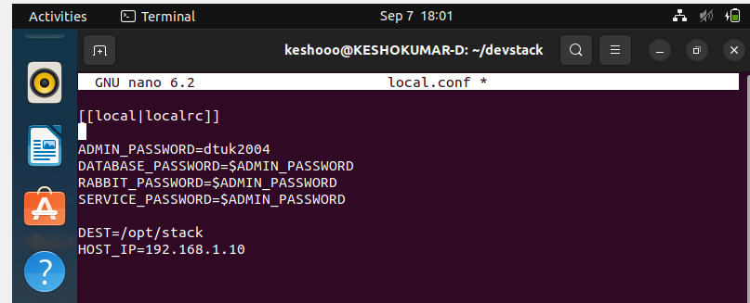
10)Run the openstack by the ./stack.sh
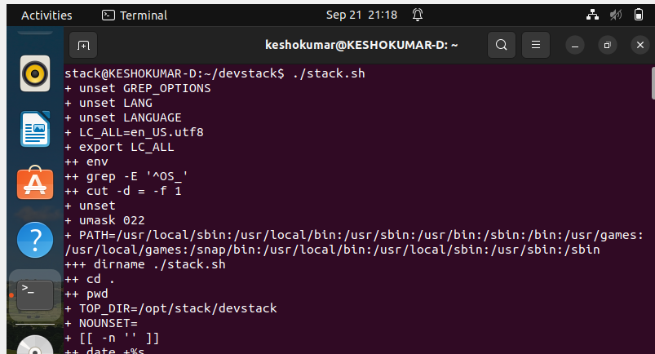
11) Visit the IP address that you have configured in the local.conf and login with the password configured in the local.conf
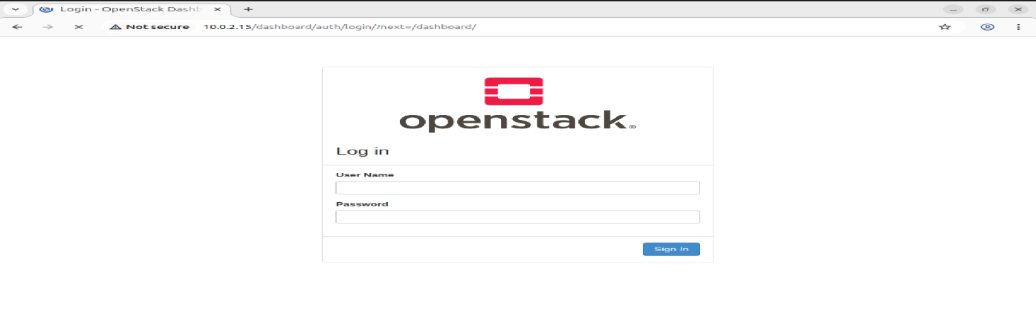

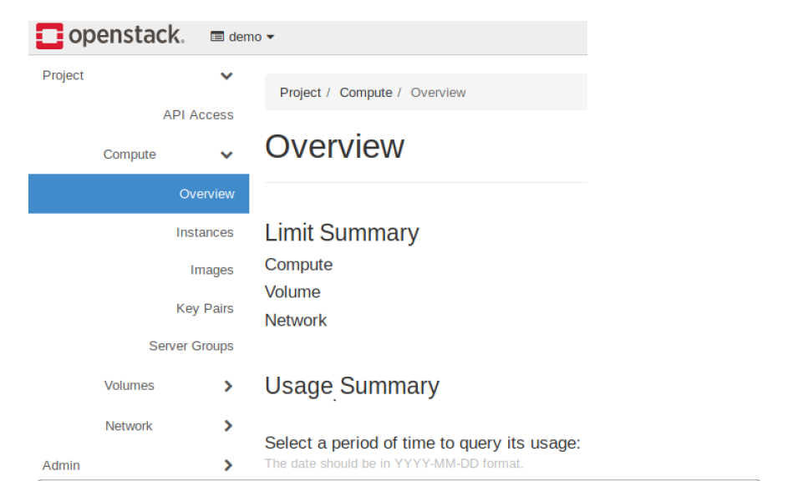
12) Create a Virtual Machine using openstack glace service using the following command
- Source OpenStack Credentials.
source devstack/openrc admin admin
(Replace admin with your actual project and username if different). Verify Image and Flavor.
- Checkout the image list
openstack image list
openstack flavor list
Note the name or ID of the image and flavor you intend to use.
- Create a Key Pair (if not already done):
openstack keypair create mykey > mykey.pem
chmod 600 mykey.pem
- Create a Network
DevStack typically creates a default network. You can list existing networks:
openstack network list. If you need to create a new one, this involves creating a network, subnet, and router, and connecting them. Launch the Virtual Machine.
openstack server create --image <image_name_or_id> --flavor <flavor_name_or_id> --nic net-id=<network_id> --key-name mykey my-first-vm
Replace <image_name_or_id>, <flavor_name_or_id>, and <network_id> with your chosen values. my-first-vm is the desired name for your VM. Verify VM Status and IP Address.
openstack server list
Look for your VM and its assigned IP address. Access the VM.
ssh -i mykey.pem cirros@<vm_public_ip>

Result:
Thus the installation of openstack and creation of virtual machine in linux system has been executed successfully and output has been verified.

Ex.no:9
9) Network Virtualization – OpenVSwitch and Linux bridge
Aim:
To perform network virtualization in Linux using OpenVswitch and Linux Bridge.
OpenVswitch
OpenVSwitch (OVS) is an open-source, production-quality, multi-layer software switch designed for virtualized environments, particularly in Linux-based hypervisors. It provides virtual network connectivity to virtual machines (VMs) and serves as a foundational component in modern data centers and software-defined networks (SDNs). OVS enables network automation through programmatic extensions like the OpenFlow protocol and the OVSDB management protocol, while also supporting standard network management interfaces such as NetFlow, sFlow, and LACP
Linux bridge
A Linux bridge is a software-based network device that functions like a physical network switch, allowing multiple network interfaces (physical or virtual) to be connected and operate as a single logical network segment. It works at the data link layer (Layer 2), forwarding network traffic based on MAC addresses rather than IP addresses. Linux bridges are crucial for virtual networking, enabling virtual machines and containers to communicate with each other and with the physical network, and are often used to create isolated networks or connect different network segments

PROCEDURE:
Linux Bridge:
- Check the current network configuration.
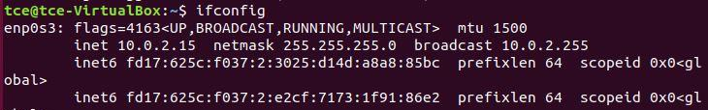
- Install and configure necessary Bridge Utilities
  - Install bridge-utils
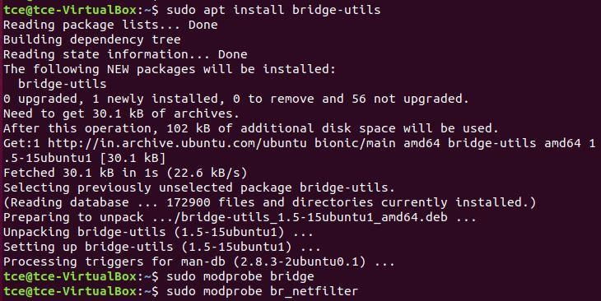
  - Load loads the bridge kernel module, which is required for bridge functionality.
  - Loads the br_netfilter kernel module, which enables netfilter (firewall) rules to be applied to traffic passing through the bridge.
- Edit the netplan configuration file and specify the configuration.
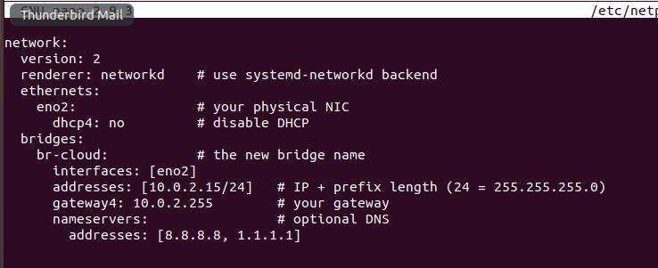
- Apply the new netplan configuration and restart the network.
- Verify the network interfaces and bridges
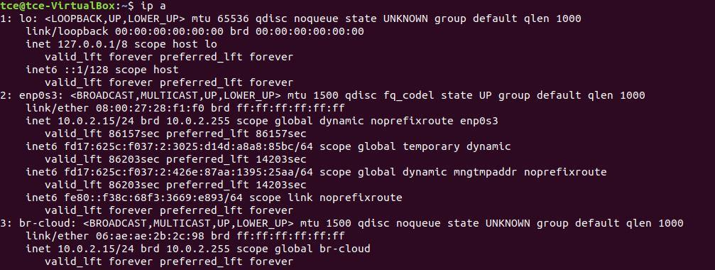
- Verify the routing table
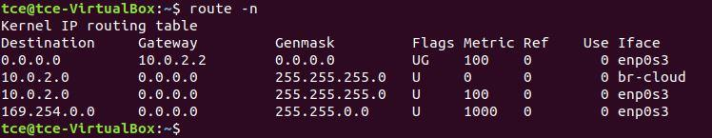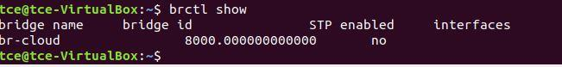
Alternatively, you can use the following commands to configure the linux bridge:
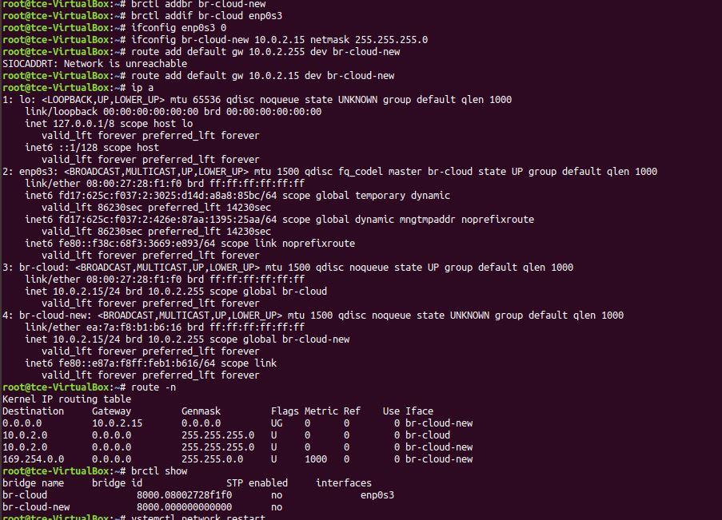
Open Virtual Switch (OpenVSwitch/OVS):
- Enter as root user.
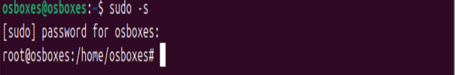
- Create 2 namespace (in my case VRF1 and VRF2)
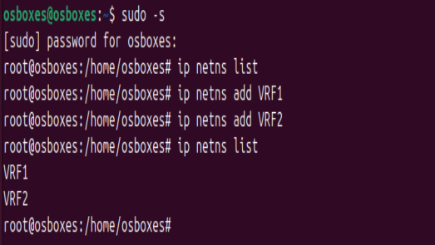
- Create 4 Virtual ethernet port to attach with bridge and namespaces.
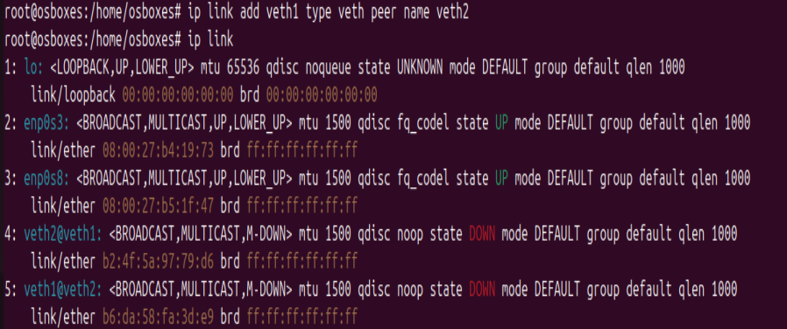
Similarly add veth3 and veth4.
- If the configuration is done to create the topology shown in the image, the links will be as
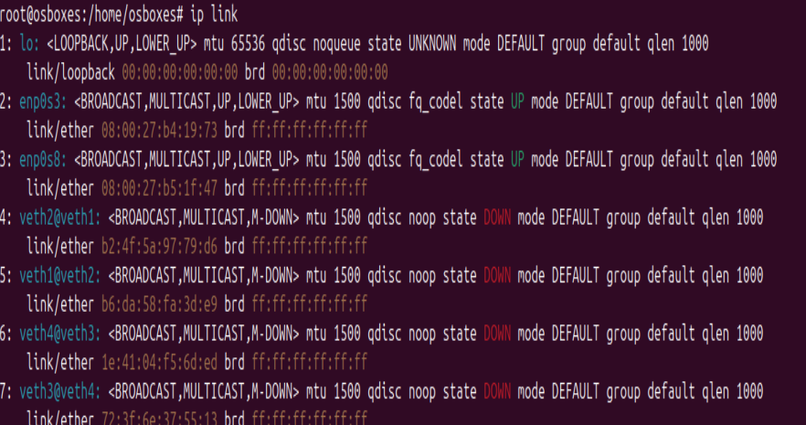
- Assign each virtual ethernet port to the particular namespace
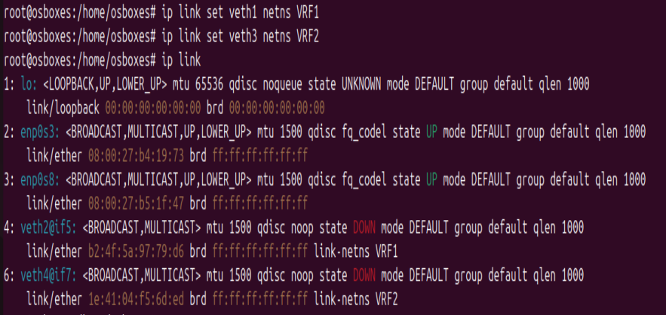
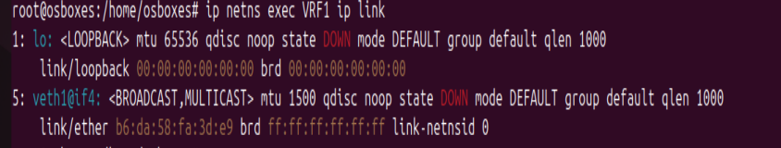
You can see that veth1 port is attached to the VRF1 namespace.
- Assign IP addresses to the virtual ethernet ports
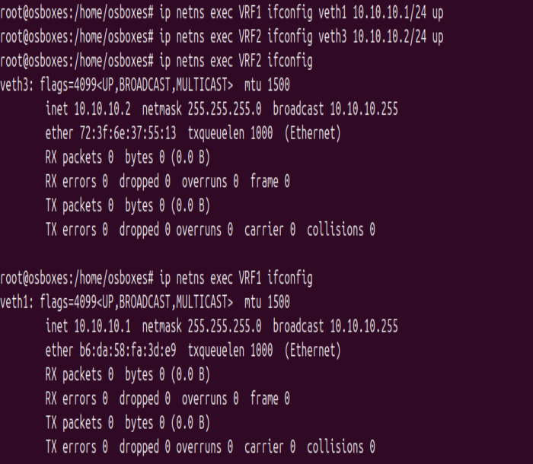
- Check the configuration using the default routing table
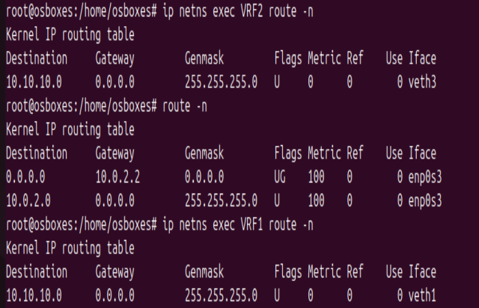
- Install openVswitch and its dependencies
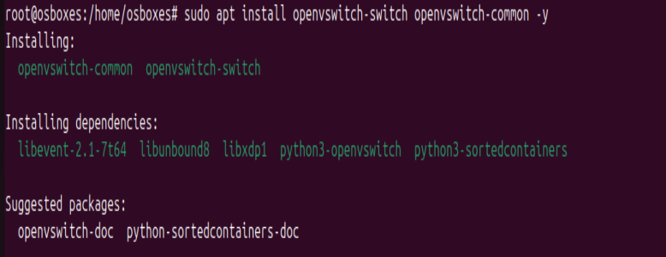

- Check the status of the openvswitch service, if off turn it on.
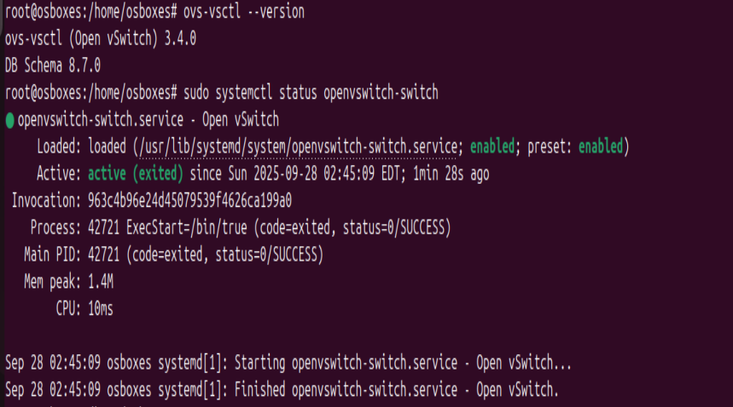
- Add the switch using ovs commandline tools and check the configuration
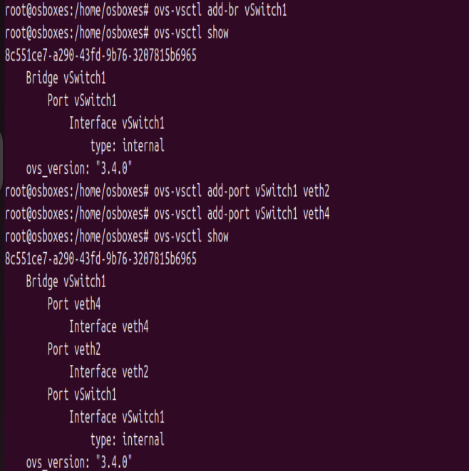
- Turn the virtual ethernet ports up and configure IP for switch check their status
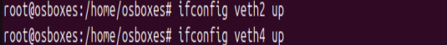
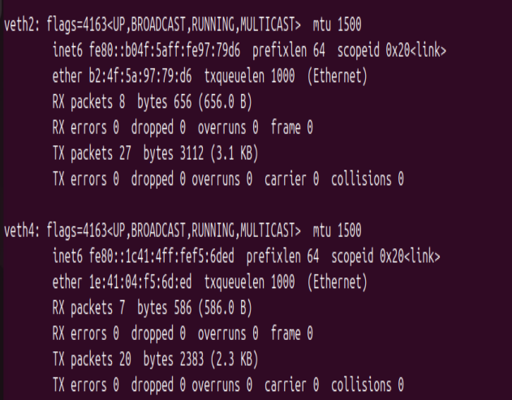
- Ping the namespace at the other end, if the configuration is done correct we can ping the Virtual namespace 2 from virtual namespace 1 via the switch (ovs bridge)
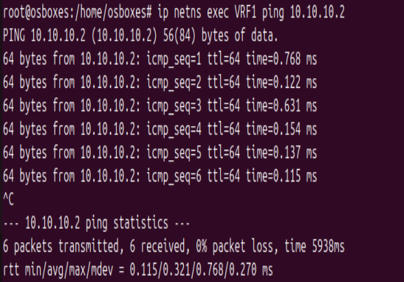
- Optionally you can turn on the spanning tree protocol (to prevent broadcast storms and network loops)
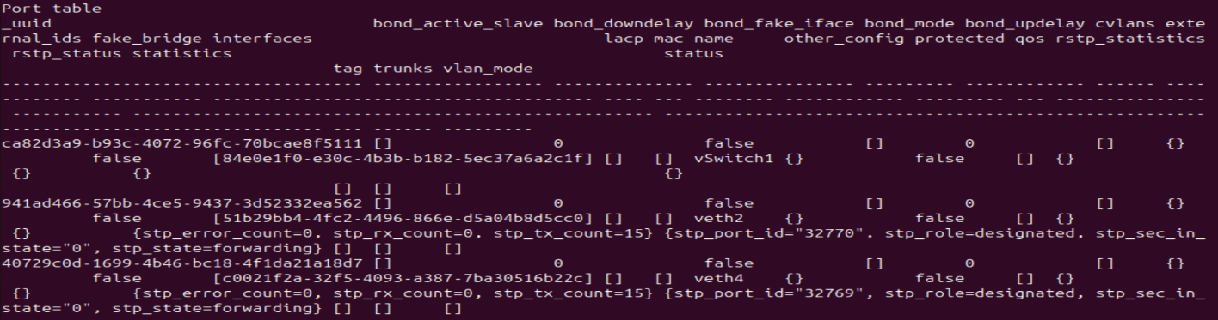
- Finally check the MAC address attached with the switch and the actual mac address of the virtual namespace device, if they match everything is done right.
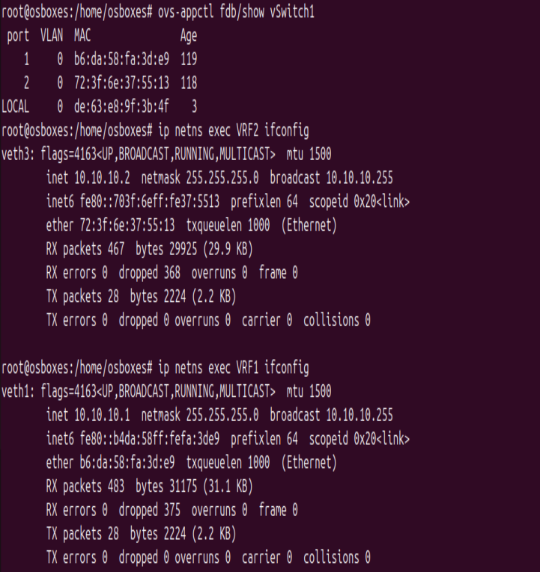

Result:
Thus, we have performed OpenVswitch and Linux Bridge successfully.
Ex.no:10
10) Creation of VHD on Windows and restoring on different host

Aim:
To create a VHD on windows and restore the same in different host
Steps:
Create a VHD on Windows
- Press Win + R, type diskmgmt.msc, and press Enter
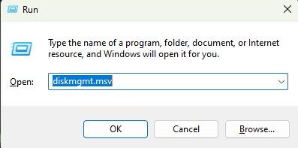
- In Disk Management, go to the Action menu → Create VHD
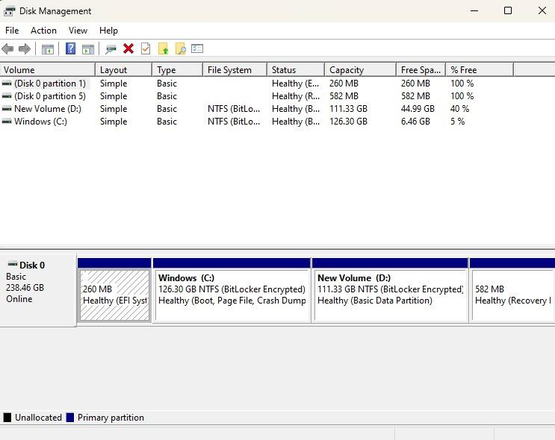
- Location → Browse and select where to save the .vhd or .vhdx file.
- Virtual Hard Disk Size (decide based on what you need).
- VHD format:VHD (compatible with older systems, max 2TB).
- Type: Fixed size → Pre-allocates the full size. Faster runtime, but uses disk space upfront.
- Dynamically expanding → Grows as data is added. Saves space initially.
- Click OK → The VHD will be created and appear in Disk Management as "Not Initialized".
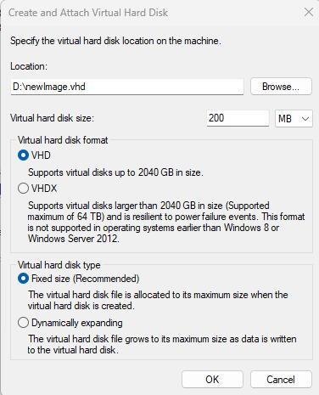
- Right-click the new disk → Initialize Disk.
- Create a new volume: Right-click unallocated space → New Simple Volume → Assign a drive letter → Format (NTFS recommended).
- Now you can use it like a normal drive.
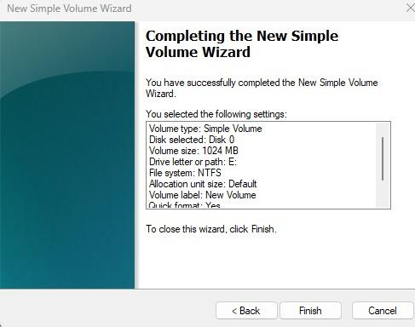

Steps to Use on Another Host
- Copy your .vhd or .vhdx file to the new machine (via external HDD, network, or cloud).
- On the new host:Open Disk Management → Action → Attach VHD.
- Browse to the .vhd file and click OK.
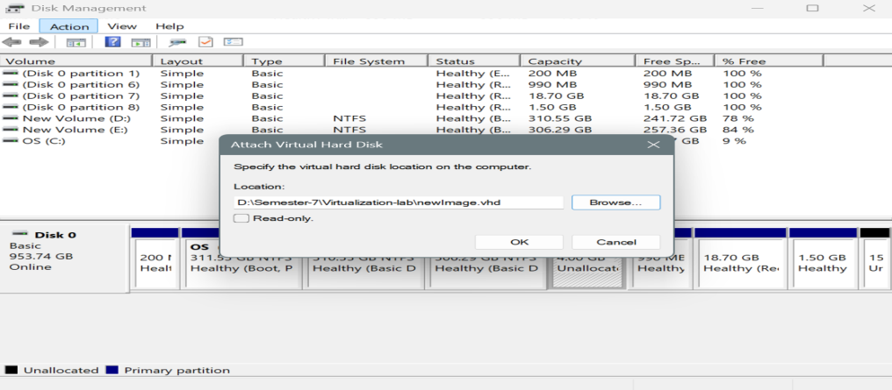
- The VHD will appear as a new drive (with the same partitions/data).
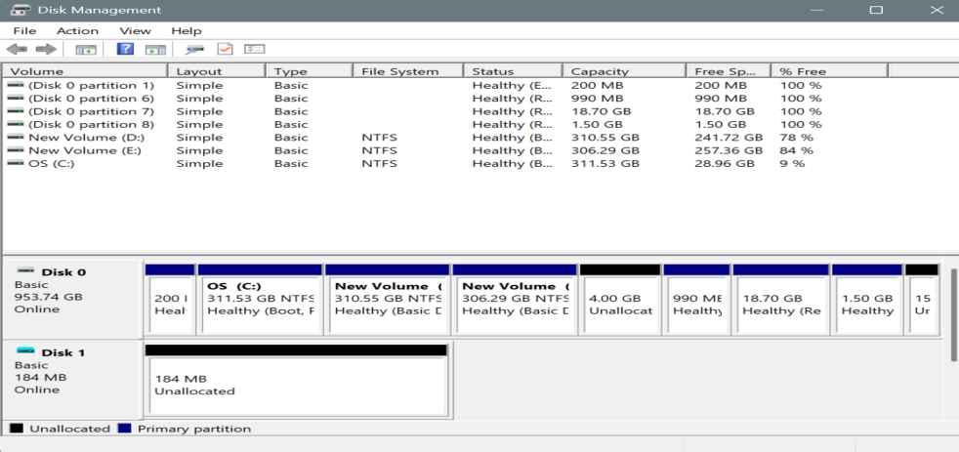

- If needed, assign a drive letter:Right-click the partition → Change Drive Letter and Paths → Assign a letter.
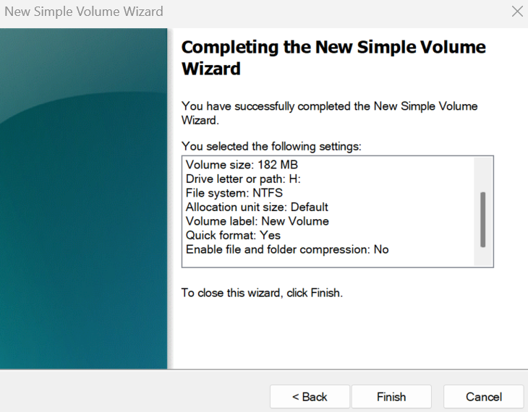
- Now you can access files just like a normal disk.
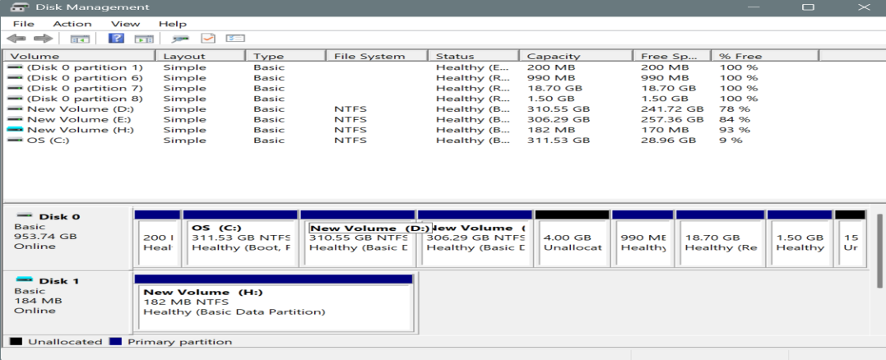

STORAGE VIRTUALIZATION:
Storage Virtualization

Step 1: Create a VM and Add Additional Storage
- Create a Linux VM
  - Open VirtualBox → Click New → Enter VM Name, Type = Linux, Version = ubuntu.
  - Allocate RAM (e.g., 2–4 GB).
  - Hard Disk: Select “Use an existing virtual hard disk file”.
  - Browse and select your VDI file.
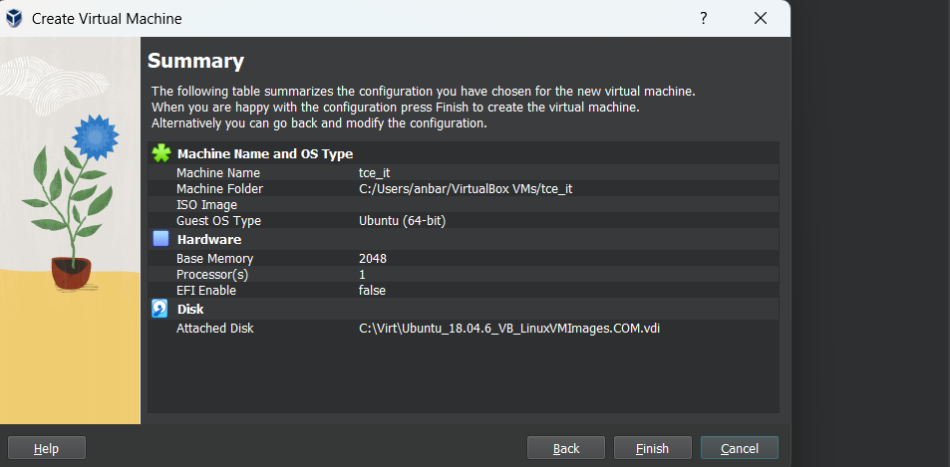
  - Click Finish.

- Add an Additional Virtual Disk
- This disk will be used for extending storage via LVM.
- In VirtualBox:
  - Select the VM → Settings → Storage.
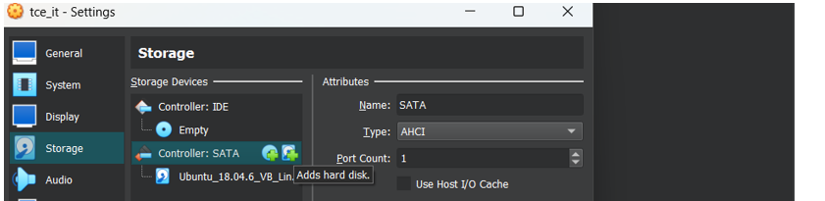
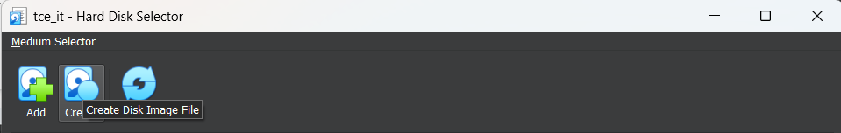
  - Click the Controller: SATA → Add Hard Disk → Create New Disk.
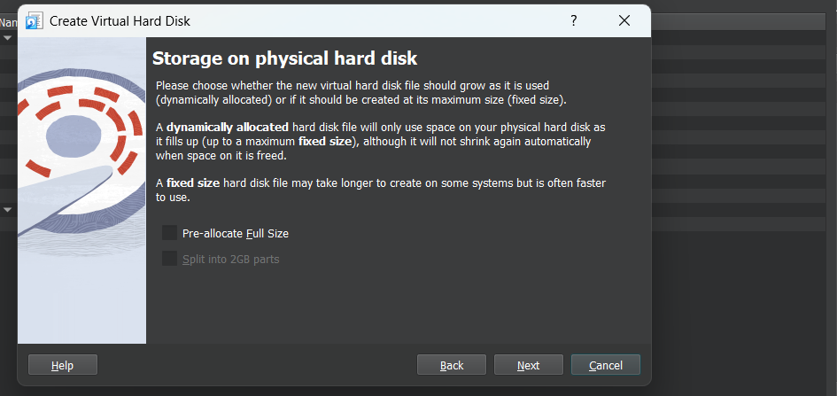
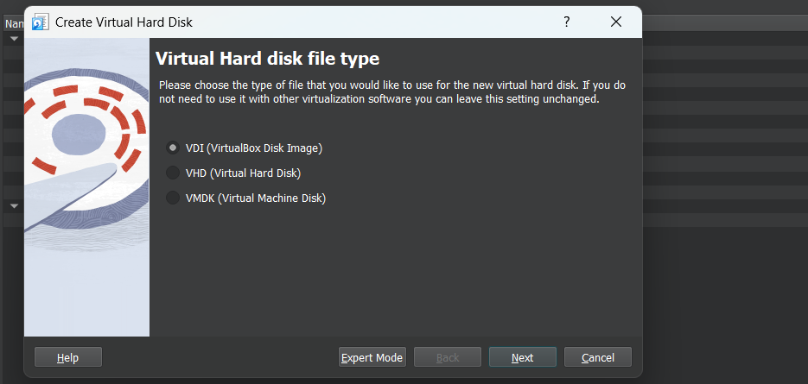
  - Choose VDI (VirtualBox Disk Image), Dynamically allocated, size = 7 GB.

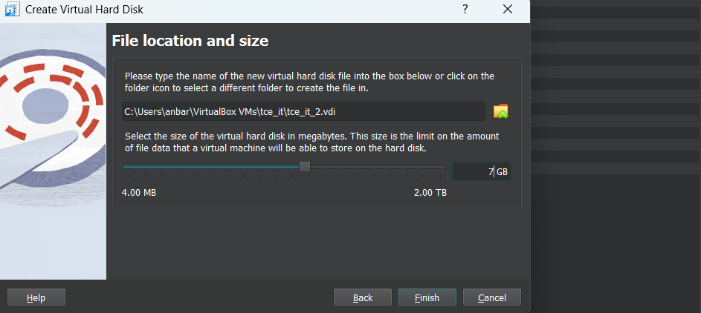
  - Click Finish.

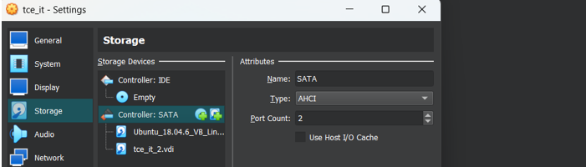
Step 2: Start the VM and Login as Root
Step 3: Check Existing Disks and LVM
# List all disks
fdisk -l
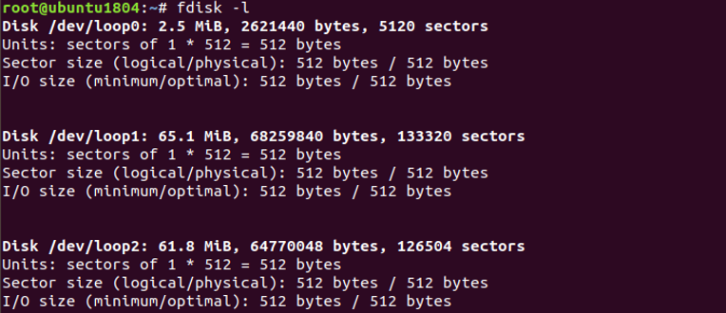
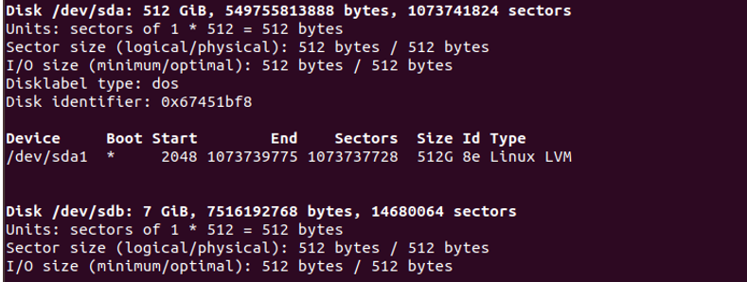
# List physical volumes
pvdisplay
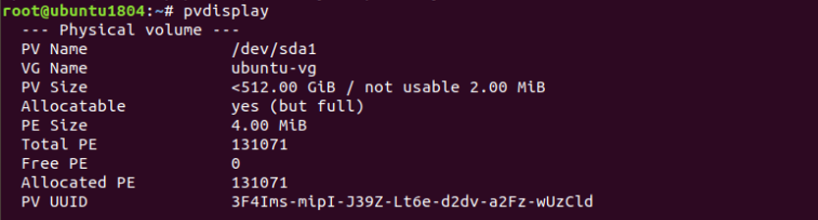
# List volume groups
vgdisplay
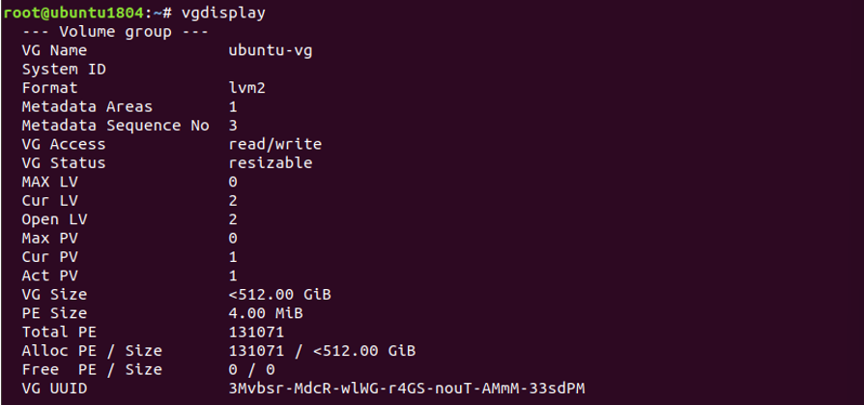

# List logical volumes
lvdisplay
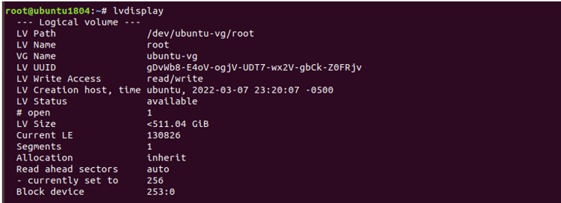
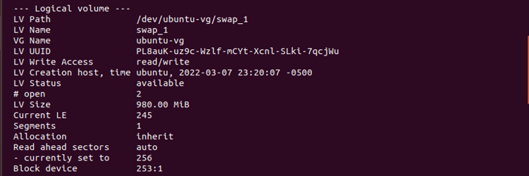
Step 4: Create Physical Volume
pvcreate /dev/sdb
Initializes the new disk for LVM.
Step 5: Extend the Volume Group
vgextend ubuntu-vg /dev/sdb
Replace cloud-vg with your existing Volume Group name.
This adds the new PV to your VG.
Step 6: Extend the Logical Volume (Root)
lvresize --size +3G /dev/ubuntu-vg/root
- +3G → amount of space to add
- /dev/cloud-vg/root → your logical volume
Alternative:
lvextend -L +3G /dev/ubuntu-vg/root
Step 7: Check Current Disk Usage
df -h
Shows current available space on /.
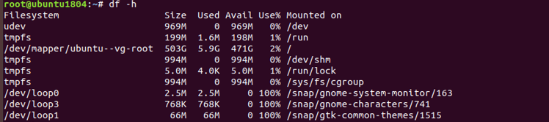
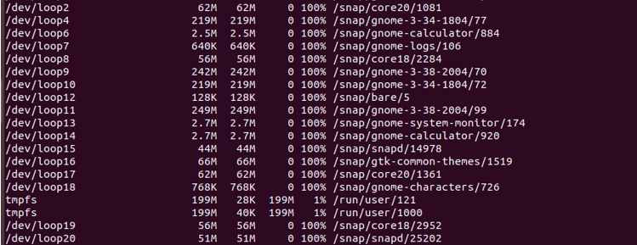

Step 8: Resize the Filesystem
resize2fs /dev/mapper/cloud--vg-root
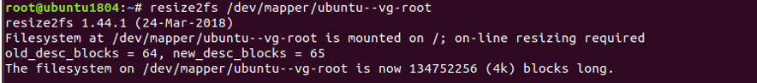
Resizes the filesystem to use the newly added space.
Step 9: Verify Disk Space
df -h
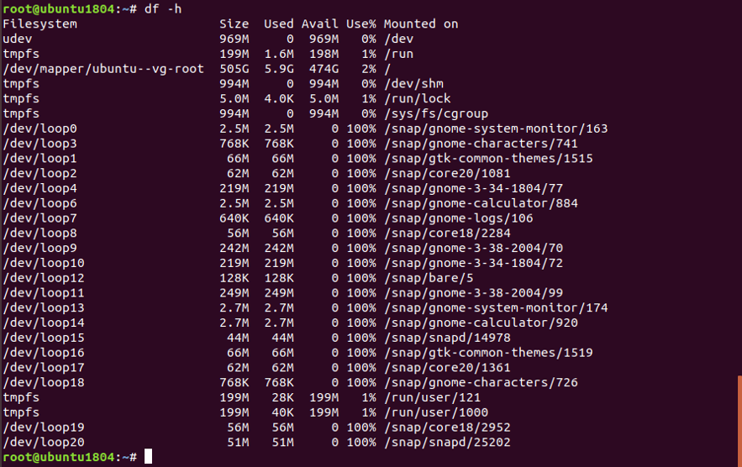
Confirm that the root filesystem now has additional 3 GB.

Result:
Thus we have created VHD on windows and restored it on another machine successfully.

1b)Review of Linux commands
AIM:
To study the linux commands and execute it using the virtualization tools (oracle virtual box)
Commands:
1. ls -> Lists files and directories in the current directory.
2. cd->Changes the current working directory.
3.pwd-> Prints the current working directory path.
4.mkdir->Creates a new directory (folder).
5. rm->Deletes files or directories. rm file.txt, rm -r myfolder (for directory)
6.Cp-> Copies files or directories.Example: cp file1.txt file2.txt
7.mv-> Moves or renames files or directories. Example: mv file.txt /tmp/ or mv old.txt new.txt
8. touch->Creates a new empty file. Example: touch test.txt
9.cat ->Definition: Displays content of a file.Example: cat file.txt
10.nano:->Definition: Terminal-based text editors.Example: nano file.txt
11.grep->Searches for patterns or keywords in files.Example: grep "error" logfile.txt
12)ps->Definition: Displays running processes. Example: ps aux
13)top->Displays system tasks and resource usage in real-time.Example: top
14) kil-> Terminates a process using its PID. Example: kill 1234
15)df->: Shows disk usage and free space of file systems. Example: df -h (human-readable)
16. du -> Shows disk usage of files and directories. Example: du -shfolder_name/
RESULT:
Thus the study of linuxcommands hasbeen studied and executed successfully and output has been verified successfully.

